A LO - To know how to use decimal notation when recording measures

Can you now write mass in three ways and convert between them?

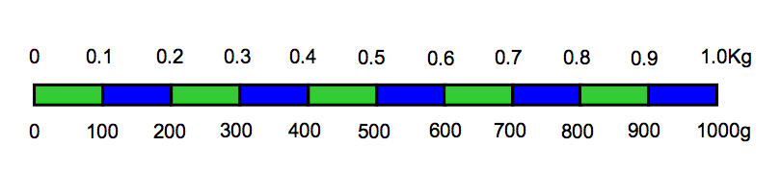

Kg | Kg and g | g
 | 1kg 250g
 |  | 1700g
2.30Kg
 | 2Kg 400g
 |  | 2800g
2.75Kg
 | 3Kg 175g
 |  | 850g
 | 1kg 90g
2.05Kg
 |  | 4020g

B LO - To know how to use decimal notation when recording measures

Can you now write mass in three ways and convert between them?

Kg | Kg and g | g
 | 1kg 250g
 |  | 1700g
2.30Kg
 | 2Kg 400g
 |  | 2800g
2.75Kg
 | 3Kg 700g
 |  | 800g
 | 1kg 900g
2.25Kg
 |  | 4800g
C LO - To know how to use decimal notation when recording measures

Can you now write mass in three ways and convert between them?

Kg | Kg and g | g
 | 1kg 200g
 |  | 1700g
1.80Kg
 | 2Kg 200g
 |  | 2800g
1.75Kg
 | 2Kg 250g
 |  | 850g
 | 1kg 500g
2.50Kg
 |  | 2800g

