Year 4 Area & Perimeter

Name: ………………………………………………………………………

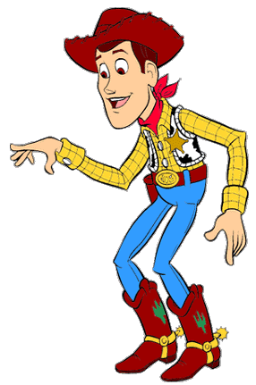LO: To be able to find the area and perimeter of rectangles and compound shapes.

I need to round up the cows in a pen. Look at these pens. I need to know how long the fence (or perimeter) is and how big they are (or area) to see how many cows they will hold, can you help?

Area: . . . . . . . . . . . . .

Perimeter: . . . . . . . . . . . . .

8m

B)

A)

17m

15m

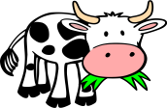

9m

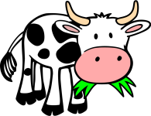

Area: . . . . . . . . . . . . .

Perimeter: . . . . . . . . . . . . .



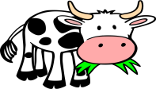

C)

15m

22m

D)

10m

15m

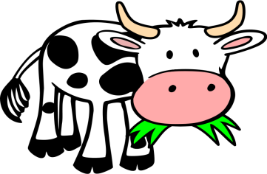

Area: . . . . . . . . . . . . .

Perimeter: . . . . . . . . . . . . .

Area: . . . . . . . . . . . . .

Perimeter: . . . . . . . . . . . . .



Area: . . . . . . . . . . . . .

Perimeter: . . . . . . . . . . . . .

F)

5m

7m

10m

E)

8m

12m

8m

6m

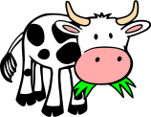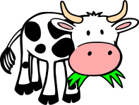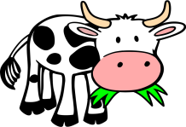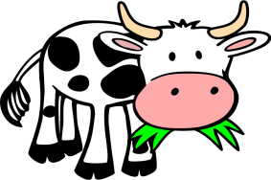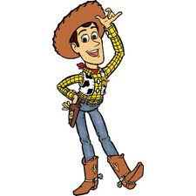

Area: . . . . . . . . . . . . .

Perimeter: . . . . . . . . . . . . .

Area: . . . . . . . . . . . . .

Perimeter: . . . . . . . . . . . . .

Area: . . . . . . . . . . . . .

Perimeter: . . . . . . . . . . . . .

H)

G)

10m

9m

13m

22m

12m

14m

18m

25m

7m

Make sure you include all the measurements. Some are missing!

18m

13m

17m