Changing adding to multiplication

Multiplying is a quicker way of showing a long adding sum of the same number, for example

apples + + becomes 3 x 2

Which means 3 sets x the 2 apples.

Task: turn the adding up below into a multiplying sum like the example above. You don’t have to write the answer.

1.  ++
+ becomes ………………………………………

2. + becomes …………………………………………

3.  + +
+ becomes …………………………………………
4.  + + becomes …………………………………

5. +++
+ becomes ……………………………………

6.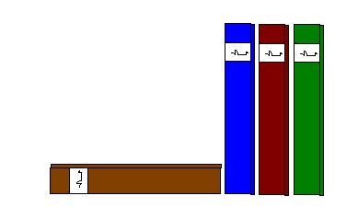++ + becomes…………………………………

Try these:

6 + 6 + 6 + 6 + 6 becomes …………………………………

8 + 8 + 8 + 8 + 8 + 8 becomes …………………………………

7 + 7 + 7 + 7 + 7 becomes …………………………………

