Comparing sizes
A B Size
What would you say about A?
A is bigger than B.
What would you say about B?
B is smaller than A.
A B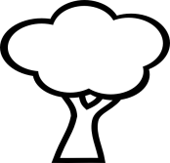 Height
Now try for yourself
What would you say about A?
?
What would you say about B?
?

A
B
What would you say about A?
?
What would you say about B?
?
How can you tell the difference between the two?
True or false
The tower is taller than the tree ?

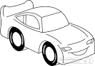
The car is longer than the lorry ?

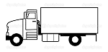

The plate is smaller than the bowl?
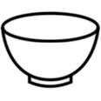
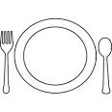
The flag pole is shorter than the tree?
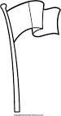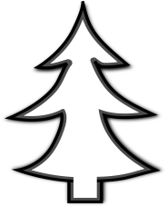
Draw a ball bigger than this.
Draw a line longer than this.

Draw a box bigger than this.

Draw a stick man taller than this.

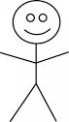
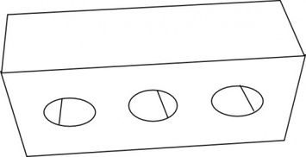
Draw a brick shorter than this.

How would you describe A,B and C? Size
A B C
- A is bigger than b or c.
- B is smaller than A or C.
- C is smaller than A and bigger than B.
How would you describe A,B and C? Height
A 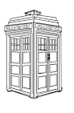 B C

How would you describe A,B and C? Height
A B C

How would you describe A,B and C? Length
A
B
C

