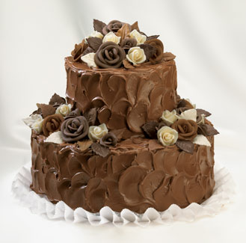
Cooking Multiplication!
WALT: use our multiplication knowledge to solve problems
Recipe:
This recipe makes a batch of 12 cupcakes
- 150ml natural yogurt
- 3 eggs , beaten
- 1 tsp vanilla extract
- 175g golden caster sugar
- 140g self-raising flour
- 1 tsp baking powder
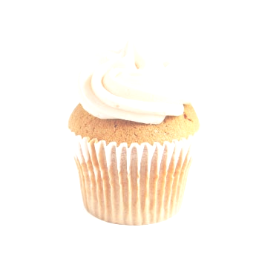
- 100g ground almonds
- 175g unsalted butter , melted
Questions:
Remember to show your workings and include the units in your answer.
- How many eggs would I need if I wanted to make 24 cupcakes?

- How much unsalted butter would I need to make 24 cupcakes?

- How much natural yogurt would I need to make 3 batches of cupcakes?

- How much golden castor sugar would I need to make 48 cupcakes?

- How many teaspoons of vanilla extract would I need to make 96 cupcakes?

- How many eggs would I need to make 120 cupcakes?

- How much self-raising flour would I need to make 2 batches of cupcakes?

- If there were 96 people at a party, how many batches of cakes would I need to make if everyone was to have one cupcake each?

Cooking Multiplication!
WALT: use our multiplication knowledge to solve problems
Recipe:
This recipe makes a batch of 12 cupcakes
- 2 pots of yogurt
- 3 eggs
- 1 teaspoon of vanilla extract
- 4 packets of sugar
- 3 packets of flour
- 6 teaspoon of baking powder
- 5 packets of almonds
- 7 grams of butter
Questions:
Remember to show your workings and include the units in your answer.
- How many eggs would I need if I wanted to make 24 cupcakes?

- How much butter would I need to make 2 batches of cupcakes?

- How many pots of natural yogurt would I need to make 3 batches of cupcakes?

- How many packets of sugar would I need to make 48 cupcakes?

- How many teaspoons of vanilla extract would I need to make 96 cupcakes?

- How many eggs would I need to make 9 batches of cupcakes?

- How many packets of flour would I need to make 7 batches of cupcakes?

- If there were 48 people at a party, how many batches of cakes would I need to make if everyone was to have one cupcake each?

