11.3.11 WALT: count in groups

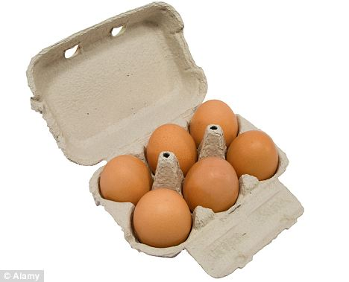
1. How many eggs in 1 box?

2. How many eggs in 3 boxes?


3. How many legs does 1 dog have?

4. How many legs do 4 dogs have?


5. How many oranges in 1 bowl?

6. How many oranges in 5 bowls?

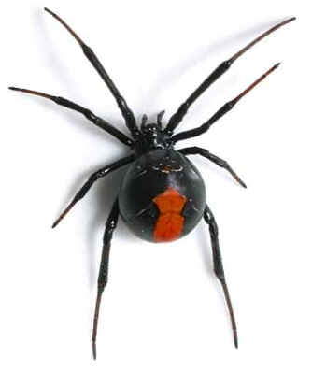

7. How many legs on 1 spider?

8. How many legs on 3 spiders?

