Average December temperatures 2012 of some countries entering the Olympics

Algeria 17⁰ | 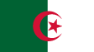  Fill in the temperatures below, and compare using more than, less than and equal to signs.  EXAMPLE:  Australia Spain  ______ ______  - Brazil Greece  ______ ______  - India France  ______ ______  - Algeria Ukraine  ______ ______  - France Australia  ______ ______  - Finland Sweden  ______ ______  - Team GB! India  ______ ______  - Algeria Norway  ______ ______  - Finland France  ______ ______  - Spain Ukraine  ______ ______  - India Sweden  ______ ______  - Team GB! China  ______ ______  - Finland Norway  ______ ______
Australia 39⁰ | 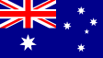
Brazil 33⁰ | 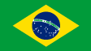
Canada ¯20⁰ | 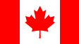
China ¯5⁰ | 
Finland ¯7⁰ | 
France 7⁰ | 
Great Britain 6⁰ | 
Greece 13⁰ | 
India 26⁰ | 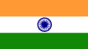
Norway ¯10⁰ | 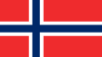
Russia ¯29⁰ | 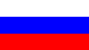
Spain 11⁰ | 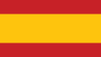
Sweden ¯7⁰ | 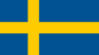
USA ¯3⁰ | 
Ukraine 0⁰ | 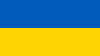

Average December temperatures 2012 of some countries entering the Olympics

Algeria 17⁰ | - China USA  ______ ______  - Russia Canada  ______ ______  - Ukraine USA  ______ ______  EXAMPLE:  Team GB! Canada Russia  ______ ______ ______  - Canada Russia Team GB!  ______ ______ ______  - Russia Team GB! Canada  ______ ______ ______  - Norway Spain Sweden  ______ ______ ______  - Spain Norway Sweden  ______ ______ ______  - Sweden Spain Norway  ______ ______ ______  - China Finland USA  ______ ______ ______  - USA Finland China  ______ ______ ______  - Finland USA China  ______ ______ ______  - Russia India Ukraine Greece  ______ ______ ______ ______
Australia 39⁰
Brazil 33⁰
Canada ¯20⁰
China ¯5⁰
Finland ¯7⁰
France 7⁰
Great Britain 6⁰
Greece 13⁰
India 26⁰
Norway ¯10⁰
Russia ¯29⁰
Spain 11⁰
Sweden ¯7⁰
USA ¯3⁰
Ukraine 0⁰

