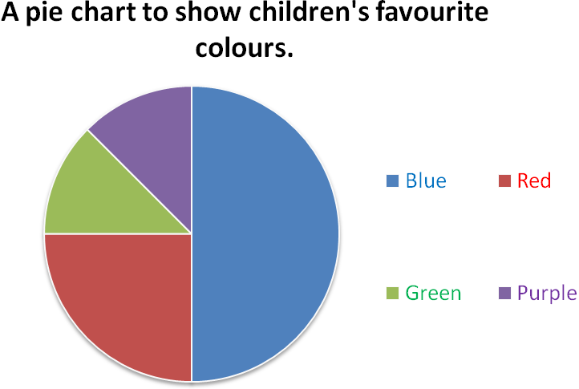
Altogether 40 children were asked what their favourite colour is.

How many children chose blue?

How many children chose red?

How many children chose green?

How many children chose purple?
Which colour is the most popular?
Which colours are the least popular?

Imagine now that 80 children were asked but the pie chart stayed exactly the same. How many children chose each colour this time?

Blue =

Red =

Green =

Purple =
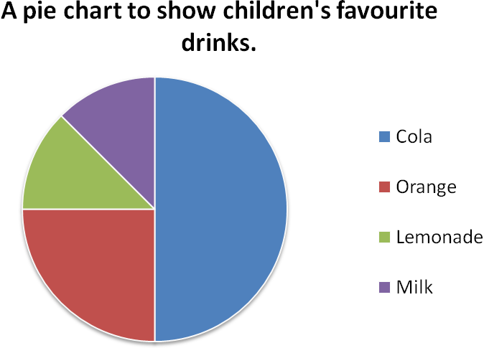
Altogether 40 children were asked what their favourite drink is.

How many children chose cola?

How many children chose orange?

How many children chose lemonade?

How many children chose milk?

Which drink is the most popular?

Which drinks are the least popular?

Imagine now that 120 children were asked but the pie chart stayed exactly the same. How many children chose each drink this time?

Cola =

Orange =

Lemonade =

Milk =
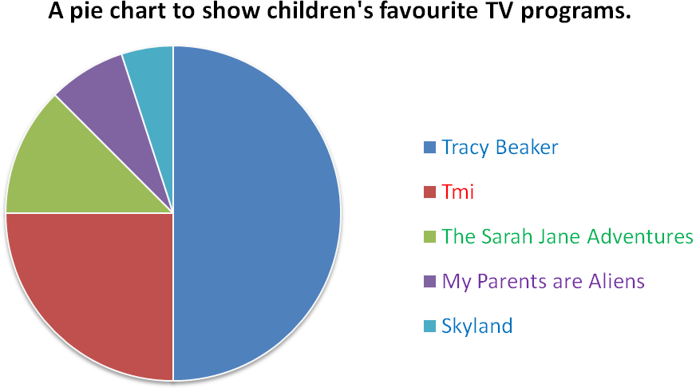
Altogether 80 children were asked what their favourite TV show is.
How many children chose Tracy Beaker?

How many children chose Tmi?

How many children chose The Sarah Jane Adventures?

How many children chose My Parents are Aliens?

How many children chose Skyland?

What conclusions can we draw from this data?

Imagine now that 104 children were asked but the pie chart stayed exactly the same. How many children chose each programme this time?

Tracy Beaker =
Tmi =
The Sarah Jane Adventures=
My Parents are Aliens =
Skyland =
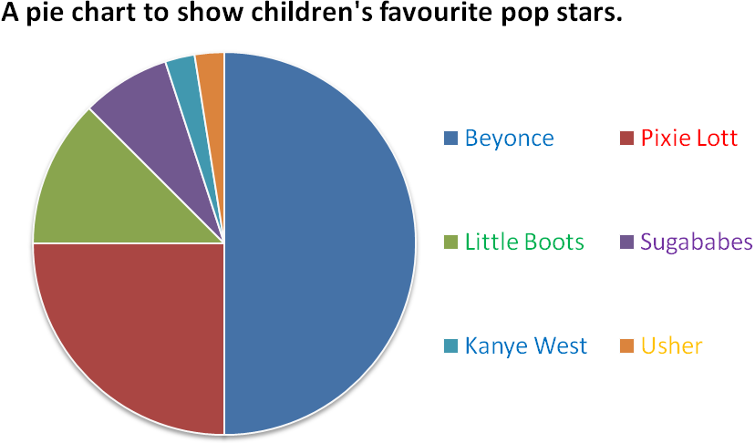
Altogether 112 children were asked who their favourite pop star is.

How many children chose Beyonce?

How many children chose Pixie Lott?

How many children chose Little Boots?

How many children chose Sugababes?

How many children chose Kanye West and Usher?

What conclusions can we draw from this data?

How many more children preferred Beyonce to Pixie Lott?

How many children chose Sugababes, Kanye West and Usher altogether?

What was the difference in popularity between Pixie Lott and Little Boots?

Create your own question for this data:
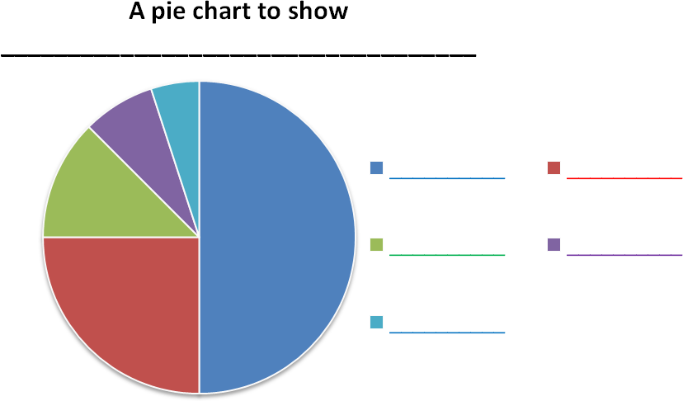
Altogether ____ children were asked _________________________________.

Using the pie chart above create your own set of data and questions about the data. You can choose how many children were asked.
Don’t forget to add the chart title and data labels.
You must be able to answer your own questions (but don’t write them on the sheet – keep them to yourself for now).

