Number bonds to 10

0 and 10 are big strong men

1 and 9 are feeling fine

2 and 8 are never late

3 and 7 come from Devon

4 and 6 like to play tricks

5 and 5 come alive

6 and 4 hold open the door

7 and 3 visit for tea

8 and 2 are feeling blue

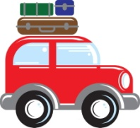 9 and 1 have just gone

10 and 0 are superheroes.

