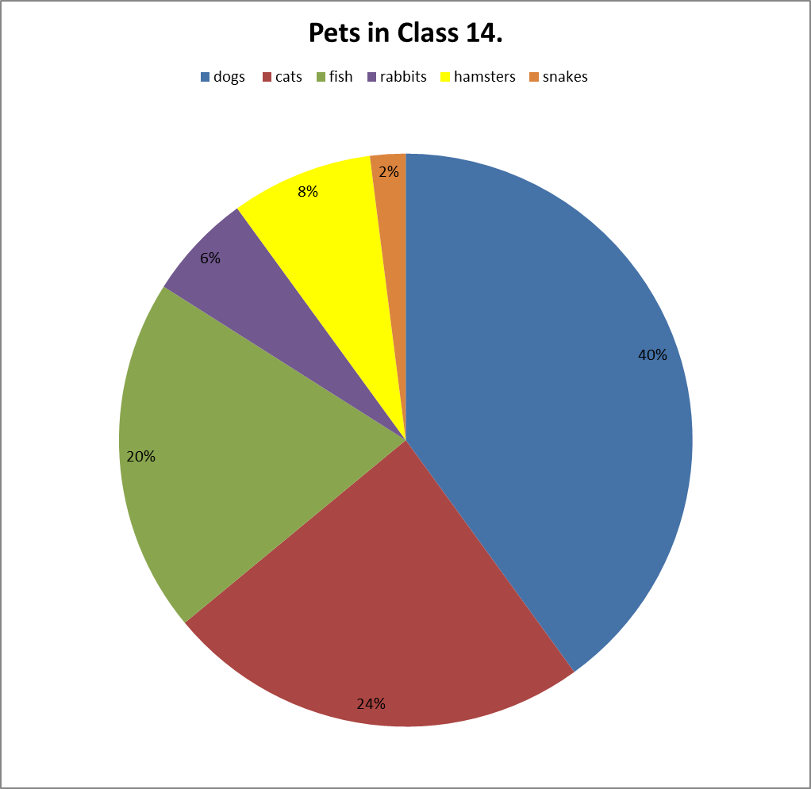
The pie chart shows the popularity of pets within Class 14. The children have 50 pets between them.
- How many dogs do the children have between them?
- How many snakes do they have?
- What is the difference in popularity between rabbits and hamsters?
- Can you tell if ALL the children in the class have got a pet?
- What fraction of the animals is a fish?
- How many more dogs are there than cats?
- If the numbers of all animals was doubled, would the pie chart look any different? Why?
- Work out the number of animals in each section and now draw the information in a bar chart instead of a pie chart.

