Lines of Symmetry
Draw all the lines of symmetry on the shapes below:

……………… lines of symmetry …………………………lines of symmetry

……………… lines of symmetry …………………………lines of symmetry

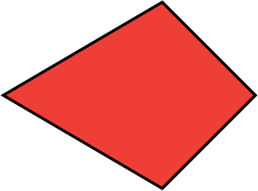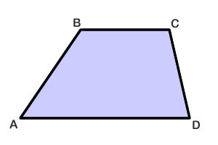

……………… lines of symmetry …………………………lines of symmetry

