Reflection

Reflect the shape in all four quadrants

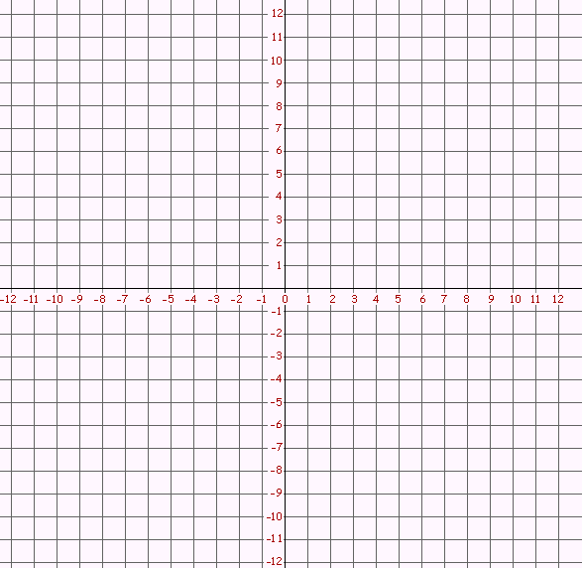

1
A
D
B
C

Label the shapes 1,2,3 and 4.
List the new coordinates in your book.

Label the shapes 1,2,3 and 4.
List the new coordinates in your book

Reflection in 4 Quadrants

Section A

- Draw a graph with 4 quadrants from 10 to -10.
- Plot the points (3,3) (7,3) (7,9) (3,5)
- Reflect the shape in all 4 quadrants
- Label each shape 1,2,3 and 4
- List the coordinates for each new shape

Section B

- Draw a graph with 4 quadrants from 10 to -10.
- Plot the points (-2,4) (-2,6) (-5,9) (-5,5)
(-6,1)
- Reflect the shape in all 4 quadrants
- Label each shape 1,2,3 and 4
- List the coordinates for each new shape

Section C

Repeat all of the above but with you own shape.

