CIRCLES: I can double a recipe.
How much of each ingredients do I need to make 24 cakes and 40 biscuits?
Rice krispie and peanut butter cakes
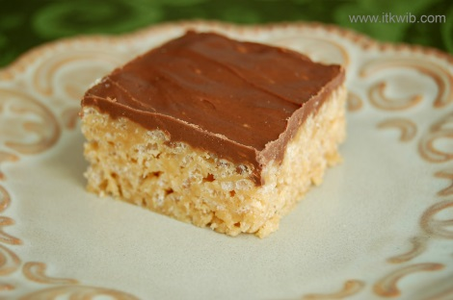
Recipe makes 12 cakes.
1 tablespoon of margarine
3 tablespoons of peanut butter
1000g of marshmallows
2000g of rice krispies
500g of chocolate
Stained glass window biscuits
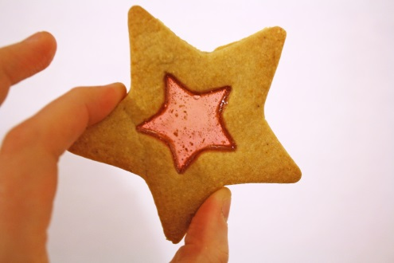
Recipe makes 20 biscuits
250g of boiled sweets
100g of butter
50g of caster sugar
200g of plain flour
1 tablespoon of milk

CHALLENGE: What if I wanted to make 48 rice krispie cakes?
(Hint – you need to double the recipe then double it again)
CIRCLES: I can double a recipe.
How much of each ingredients do I need to make 24 cakes and 40 biscuits?
Rice krispie and peanut butter cakes
Recipe makes 12 cakes.
1 tablespoon of margarine
3 tablespoons of peanut butter
1000g of marshmallows
2000g of rice krispies
500g of chocolate
Stained glass window biscuits
Recipe makes 20 biscuits
250g of boiled sweets
100g of butter
50g of caster sugar
200g of plain flour
1 tablespoon of milk

CHALLENGE: What if I wanted to make 48 rice krispie cakes?
(Hint – you need to double the recipe then double it again)

