Shape Sequences 3
LI: We are learning to identify, describe and continue sequences.

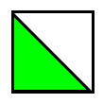












Have some fun creating some shape sequences for your friends to identify, describe and continue.
Shape Sequences 2
LI: We are learning to identify, describe and continue sequences.




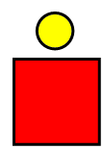

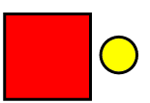
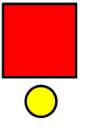
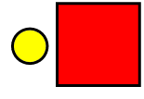

Have some fun creating some shape sequences for your friends to identify, describe and continue.
Shape Sequences 1
LI: We are learning to identify, describe and continue sequences.






Have some fun creating some shape sequences for your friends to identify, describe and continue.

