**Translation**

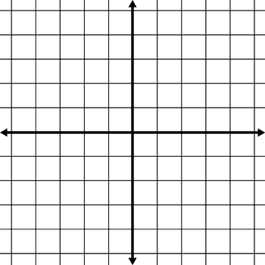

**Move 5 units left**

**Move 6 units down**



**Move 4 units down**

**Move 6 units right**

**A**

**B**

**C**

**D**

**A**

**B**

**C**

**A**

**B**

**C**

**D**

**A**

**B**

**C**

L.O: To be able to draw the position of a shape after translation.



**Move 6 units right**

**Move 7 units left and 6 units up**



**Move 6 units left and 6 units down**

**Move 7 units left and 6 units up**

**A**

**B**

**C**

**D**

**A**

**B**

**C**

**A**

**B**

**C**

**D**

**A**

**B**

**C**