Ratio
Here is a recipe for fruit smoothies
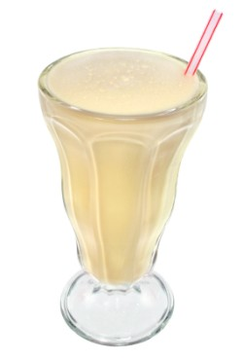
Recipe
10 strawberries
½ litre of orange juice
250ml yogurt
1 banana

Makes 2 smoothies

Lucy uses the recipe to make 4 smoothies.
How much of the ingredients will she need?

Strawberries | Orange juice | yogurt | banana | Number of smoothies

If she uses 1 litre of yogurt, how much of the other ingredients will she need and how many smoothies will this make?

Strawberries | Orange juice | yogurt | banana | Number of smoothies

EXTENSION- How much of each ingredient would she need if she only wanted to make 1 smoothie?

