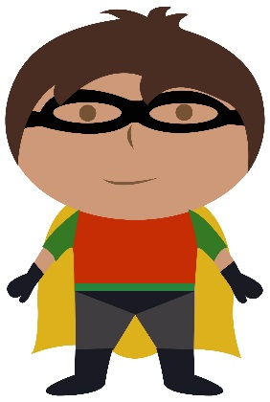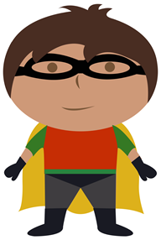

20

17

6

14

11

5

1



0-20 ordering activity.

Cut and stick the superheroes into the correct order.

9

16

18

4

13

8

3

10

19

2

15

12

7