Name: Date:
Sweet Bags (Higher)
L.O: To be able to identify ratio and proportions of quantities.
1. Draw and shade in the correct number of sweets in each bag. The total number of sweets and the ratio of each colour are given.
2. For each bag use the same ratio of colours to find equivalent ratios.
3. Identify the proportions for each sweet bag.

- 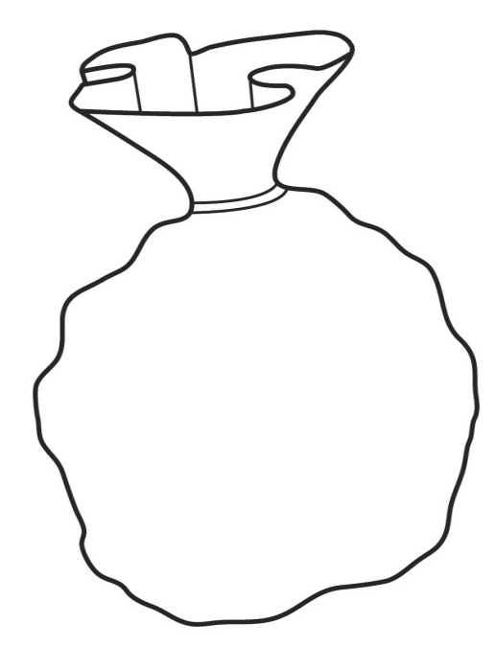
Proportion of yellow:
Proportion of purple:
Proportion of yellow:
Proportion of purple:
Proportion of yellow:
Proportion of purple:
____ sweets
Yellow to Purple
1:3
____ sweets
Yellow to Purple
1:3
20 sweets
Yellow to Purple
1:3

Proportion of yellow:
Proportion of purple:
Proportion of yellow:
Proportion of purple:
Proportion of yellow:
Proportion of purple:
____ sweets
Yellow to Purple
4:5
____ sweets
Yellow to Purple
4:5
27 sweets
Yellow to purple
4:5
15 sweets
Red to Green
4:1
12 sweets
Red to Green
1:2
15 sweets
Red to Green
4:1
12 sweets
Red to Green
1:2
12 sweets
Red to Green
1:2

Proportion of yellow:
Proportion of purple:
Proportion of yellow:
Proportion of purple:
Proportion of yellow:
Proportion of purple:
____ sweets
Yellow to Purple
9:3
____ sweets
Yellow to Purple
9:3
36 sweets
Yellow to Purple
9:3

Proportion of yellow:
Proportion of purple:
Proportion of yellow:
Proportion of purple:
Proportion of yellow:
Proportion of purple:
____ sweets
Yellow to Purple
7:4
____ sweets
Yellow to Purple
7:4
33 sweets
Yellow to Purple
7:4
15 sweets
Red to Green
4:1
12 sweets
Red to Green
1:2
15 sweets
Red to Green
4:1
12 sweets
Red to Green
1:2
____ sweets
Yellow to Purple
6:9
____ sweets
Yellow to Purple
6:9
45 sweets
Yellow to Purple
6:9
Proportion of yellow:
Proportion of purple:
Proportion of yellow:
Proportion of purple:
Proportion of yellow:
Proportion of purple:

