Name: Date:
Sweet Bags (Lower)
L.O: To be able to identify ratio.
Draw and shade in the correct number of sweets in each bag. The total number of sweets and the ratio of each colour are given.

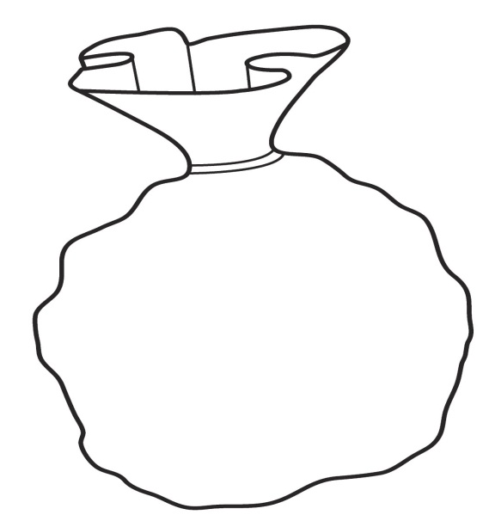
15 sweets
Red to Green
4:1
12 sweets
Red to Green
1:2
16 sweets
Red to Green
3:5
16 sweets
Red to Green
1:3
10 sweets
Red to Green
3:2
8 sweets
Red to Green
1:3

Name: Date:
Sweet Bags (Middle)
L.O: To be able to identify ratio and proportions of quantities.
1. Draw and shade in the correct number of sweets in each bag. The total number of sweets and the ratio of each colour are given.
2. For each bag use the same ratio of colours to find equivalent ratios. (First one is done for you)

- 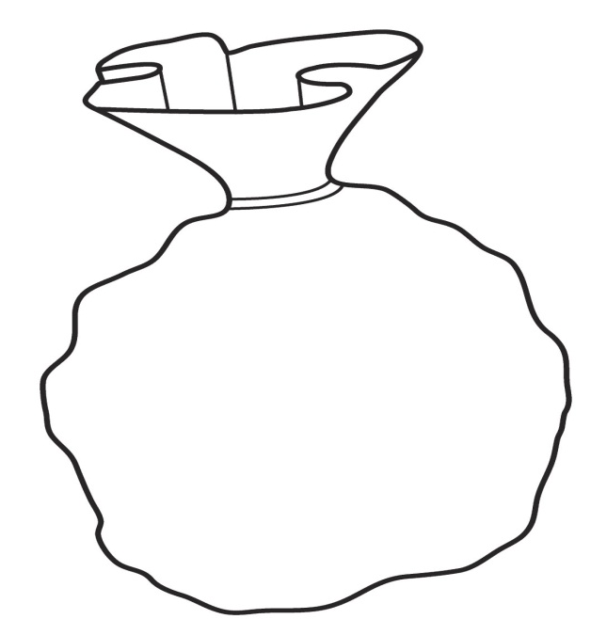
16 sweets
Orange to Blue
1:3
8 sweets
Orange to Blue
1:3

____ sweets
Orange to Blue
3:5
16 sweets
Orange to Blue
3:5
15 sweets
Red to Green
4:1
12 sweets
Red to Green
1:2
15 sweets
Red to Green
4:1
12 sweets
Red to Green
1:2
12 sweets
Red to Green
1:2

____ sweets
Orange to Blue
1:3
12 sweets
Orange to Blue
1:3

____ sweets
Orange to Blue
3:2
15 sweets
Orange to Blue
3:2

____ sweets
Orange to Blue

2:4
18 sweets
Orange to Blue
2:4
15 sweets
Red to Green
4:1
12 sweets
Red to Green
1:2
15 sweets
Red to Green
4:1
12 sweets
Red to Green
1:2

