Translation

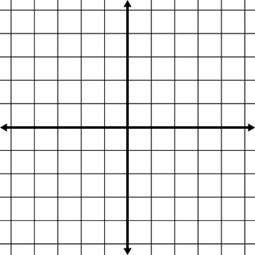
Move 5 units left and 3 units down
Move 6 units right and 5 units down
Move 2 units left and 8 units down
Move 6 units right and 5 units up
A
B
C
D
A
B
C
A
B
C
D
A
B
C
L.O: To be able to draw the position of a shape after translation.

Move 7 units left and 3 units down
Move 7 units right and 5 units up
Move 4 units right and 3 units down
Move 8 units left and 5 units up
A
B
C
D
A
B
C
A
B
C
D
A
B
C

