Using Co-ordinates to plot Translations

Use the XY grid to plot shapes using the co-ordinates provided.
1, A;(+2,-3) B;(+6,-3) C;(+2,-7) D;(+6,-7).
What shape have you drawn?…………………………………..
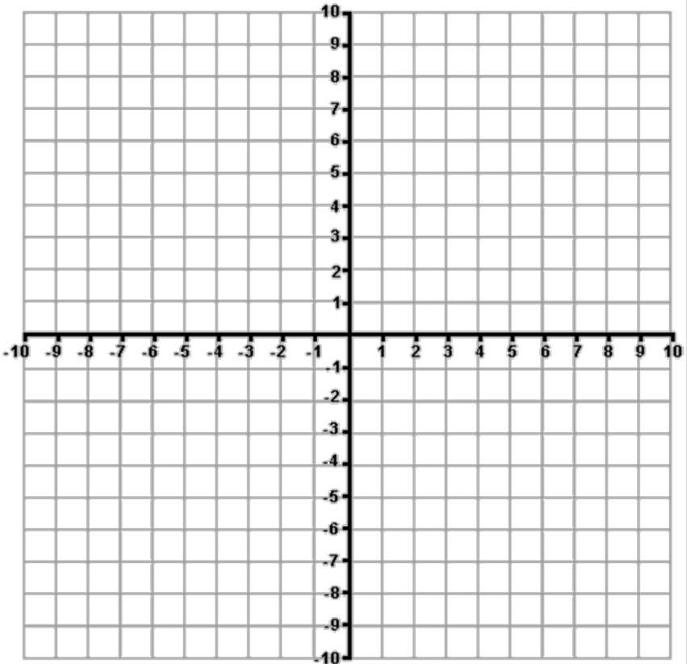
Now use the following co-ordinates to plot the shapes translation:
A;(-7,+3) B;(-3,+3) C;(-7,-1) D;(-3,-1)
Can you describe the translation in the form of a co-ordinate?
( , )
2, A;(+2,-2) B;(+6,-2) C;(+4,+3)
What shape have you drawn?…………………………………..
Now use the following co-ordinates to plot the shapes translation:
A;(+5,+5) B;(+9,+5) C;(+7,+10)
Can you describe the translation in the form of a co-ordinate?
( , )
3, A;(-8,+7) B;(-6,+7) C;(-9, +5) D;(-5,+5)
What shape have you drawn?…………………………………..
Now use the following co-ordinates to plot the shapes translation:
A;(-7,-5) B;(-7,-7) C;(-9,-4) D;(-9,-8)
Can you describe the translation in the form of a co-ordinate?
( , )
Can you describe another form of transformation that has occurred here?................................................

