Translation

L.O: To be able to draw the position of a shape after translation.

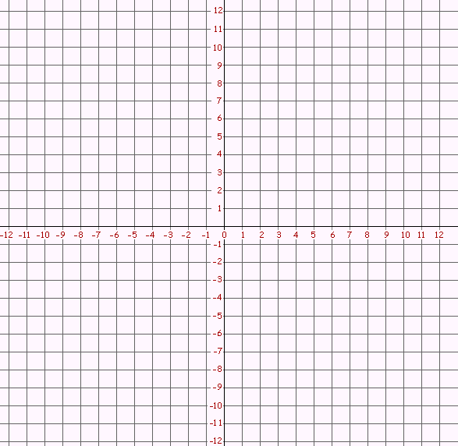
A
D
B
C
2

4
A
D
B
C

A
D
B
C
3
A
D
B
C

1

5
A
D
B
C

6
A
D
B
C

Draw the shape in the new position after translation and then label the corners of the translated shape with A1, B1, C1 & D1, and then find the co-ordinates.

Translate the shape:
1 = 5 units left and 6 units up | 4 = 2 units right and 5 units down
2 = 5 units right and 3 units down | 5 = 4 units left and 5 units up
3 = 2 units left and 4 units down | 6 = 5 units left and 6 units up

Translation cont.

Co-ordinates for the shapes:

1 = A (__, __), B (__, __), C (__, __), D (__, __)
A1 (__, __), B1 (__, __), C1 (__, __), D1 (__, __)

2 = A (__, __), B (__, __), C (__, __), D (__, __)
A1 (__, __), B1 (__, __), C1 (__, __), D1 (__, __)

3 = A (__, __), B (__, __), C (__, __), D (__, __)
A1 (__, __), B1 (__, __), C1 (__, __), D1 (__, __)

4 = A (__, __), B (__, __), C (__, __), D (__, __)
A1 (__, __), B1 (__, __), C1 (__, __), D1 (__, __)

5 = A (__, __), B (__, __), C (__, __), D (__, __)
A1 (__, __), B1 (__, __), C1 (__, __), D1 (__, __)

6 = A (__, __), B (__, __), C (__, __), D (__, __)
A1 (__, __), B1 (__, __), C1 (__, __), D1 (__, __)

