Analogue - What time will it be?
Look at the written time, can you say what it would be . . . .
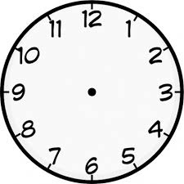

10 minutes later? 15 minutes before? 5 minutes later?

65 min before? 1h 20m later? 2h 30m before?

15 minutes later? 40 minutes before? 25 minutes later?

75 min before? 3h 35m later? 4h 20m before?

