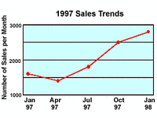
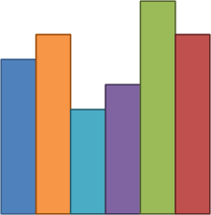
Which Graph ?

For each set of data below, draw the appropriate graph – bar chart or line graph.

- A café did a survey to find the most popular sandwiches on the menu.

Sandwich | Number of votes
Ham, cheese and pickle | 7
Chicken mayonnaise | 12
Tuna and sweetcorn | 9
Cheese and tomato | 6
Egg mayonnaise | 7

- Year 4 did a science experiment to find how the length of a spring changed when they added weights to the end. Here are their results.

Weight (g) | Length of spring (CM)
0 | 6
25 | 10
50 | 14
75 | 18
100 | 22
125 | 26
150 | 32

- What was the length of the spring when 75g was added?
- What would the length of the spring be if we added 60g?
- By how much did the spring stretch altogether?

- The Headteacher needed to know exactly how many boys and girls were in each year group.

Year Group | Boys | Girls
Nursery | 34 | 28
Reception | 25 | 40
1 | 26 | 35
2 | 28 | 32
3 | 28 | 32
4 | 24 | 33
5 | 35 | 24
6 | 24 | 35

- A lorry driver recorded how far he had travelled every 2 hours.

Time | Distance travelled (KM)
8am | 100
10am | 200
12pm | 300
2pm | 350
4pm | 425
6pm | 425

- Between 8am and 12pm how many kilometres per hour was the lorry travelling?
- Why might it have been less between 12pm and 2pm?
- What do you think might have happened to slow the lorry driver down between 2pm and 4pm?
- What time do you think the lorry driver stopped work?

Which Graph ?

For each set of data below, draw the appropriate graph – bar chart or line graph.

- A café did a survey to find the most popular sandwiches on the menu.
Sandwich | Number of votes
Ham, cheese and pickle | 7
Chicken mayonnaise | 12
Tuna and sweetcorn | 9
Cheese and tomato | 6
Egg mayonnaise | 7

- Year 4 did a science experiment to find how the length of a spring changed when they added weights to the end. Here are their results.
Weight (g) | Length of spring (CM)
0 | 6
25 | 10
50 | 14
75 | 18
100 | 22
125 | 26
150 | 32

- What was the length of the spring when 75g was added?
- What would the length of the spring be if we added 60g?
- By how much did the spring stretch altogether?

