LINGUATRIVIA French Competition: A Few Tips...

Before you enter the Linguatrivia competition this term, you need to know a few things about France: its history, geography and culture, especially this…

- GEOGRAPHY:
- Here is a map of France. You must know the main cities in France and where they are roughly located (dans le nord/le sud/l'est/l'ouest de la France): Marseille, Paris, Lyon, Bordeaux, Toulouse, Grenoble, Lille, Strasbourg, Brest, Nantes, Nancy, Nice, Toulon...
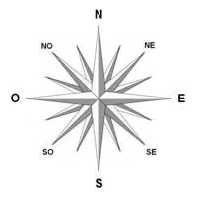
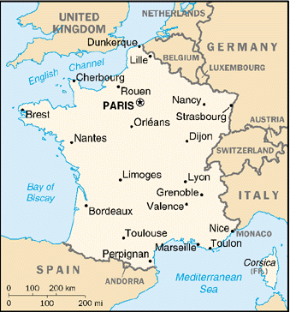

- You also need to know the countries having borders with France : l’Espagne/ l’Italie/ La Suisse/ L’Allemagne/ Le Luxembourg/ La Belgique.

- There are a few rivers ( = des rivières) in France : La Seine (in Paris), La Garonne, Le Rhin and Le Rhône are the main ones. The seas surrounding France are “la Mer Méditerrannée” in the south, “l’Océan Atlantique” in the west (or Bay of Biscay) and “la Manche” (the English Channel ) in the north.

- French is the official language of 29 countries in the world, mainly in Africa and in Europe.

- France is divided into 13 regions (including the "territorial collectivity" of “Corse” or Corsica) and is subdivided into 96 “départments” (like the Counties in the UK). The 13 ‘régions’ are :
Auvergne-Rhône-Alpes, Bourgogne Franche-Comté, Bretagne, Centre-Val de Loire, Corse, Grand-Est, Hauts-de-France, Ile-de-France, Normandie, Nouvelle Aquitaine, Occitanie, Pays de la Loire, Provence-Alpes-Côte d'Azur.

Here is a map to help you remember where regions are:
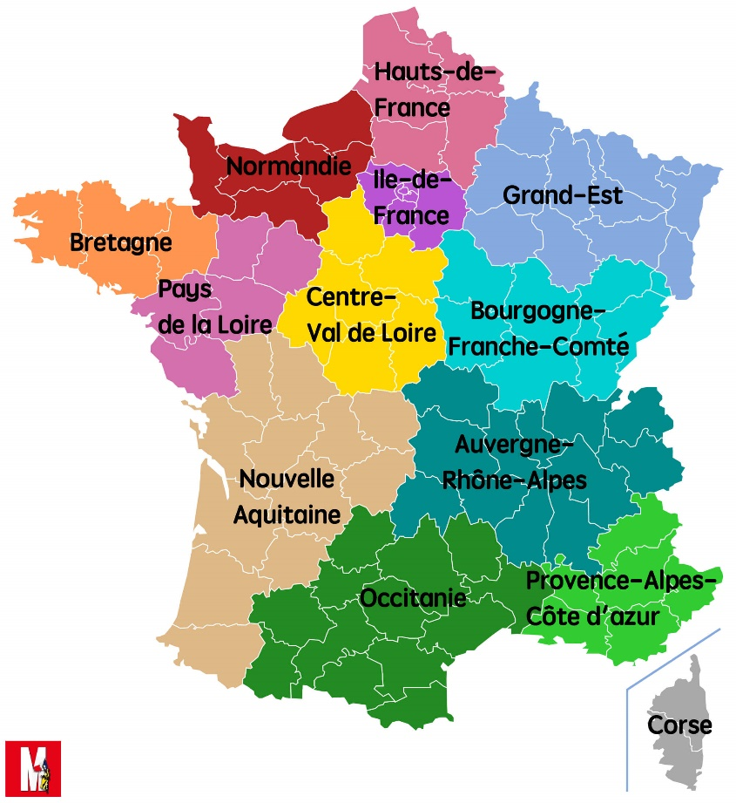
- HISTORY:

- There are around 67 million inhabitants in France. The French capital is PARIS.
- The government is a Republic (une République). The “Président de la République” is called Emmanuel Macron. The current Prime Minister (Premier Ministre) is Edouard Philippe.
- The French National Day (“La Fête Nationale”) is “le 14 juillet “ (= Bastille Day). It is a bank holiday with fireworks (= “des feux d’artifice”) and a parade on the Champs-Elysées (which is an avenue).
- The French National Anthem is called 'La Marseillaise' and was written by Rouget de Lisle.

- CULTURE:
- The Eiffel Tower ('La tour Eiffel') is 324 metres high (including the aerial). Gustave Eiffel created it.
- The most famous museum in Paris is “Le Louvre”. It houses the Mona Lisa (= “La Joconde” in French) which was painted by Italian painter Leonardo Da Vinci. There, you can see 'La pyramide du Louvre' which is made of glass (= verre) and metal. It was commissioned by former French President François Mitterrand and is surrounded by three smaller pyramids, in the main courtyard of the Louvre Palace in Paris. The large pyramid serves as the main entrance to the Louvre Museum.
- Montmartre is a famous area in Paris: painters sell their paintings on a square called “La Place du Tertre”. Montmartre was used a lot in the film called “Amélie Poulain”, starring Audrey Tautou.
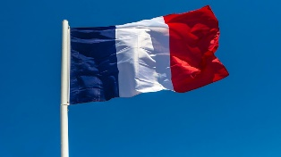
- The equivalent of Oxford Street in Paris is “Les Champs-Elysées”. It is an avenue with lots of shops.
- The French flag is bleu, blanc, rouge (blue, white, red) .

Here is a list of celebrities you should know or recognise:
- Famous actors and actresses (= acteurs et actrices):
Gérard Depardieu ( who plays Obélix)
Catherine Deneuve (« Peau d'âne », plays the Queen of England in Astérix)
Kad Merad (« Le petit Nicolas »)
Marion Cotillard (« La vie en rose »)
Jean Reno (« Godzilla », « The Pink Panther »)
Brigitte Bardot (« And God Created Woman », she is an animal activist too)
Christian Clavier (who plays Astérix)
Louis de Funès (« Rabbi Jacob », « Le Gendarme de Saint-Tropez »)
Dany Boon (« Bienvenue chez les Ch’tis »)
Omar Sy (« Intouchables », « X-Men : Days of Future Past », « Jurassic World »)

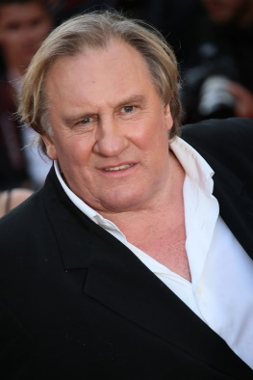 |  | 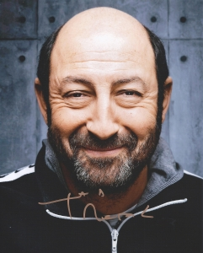 |  | 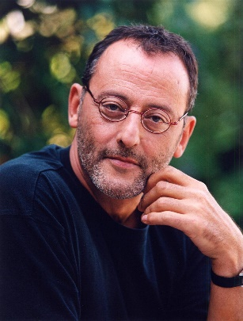
Gérard Depardieu | Catherine Deneuve | Kad  Merad | Marion  Cotillard | Jean  Reno
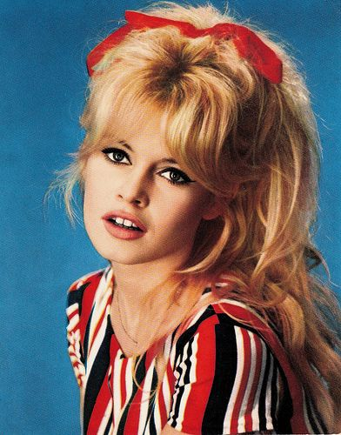 | 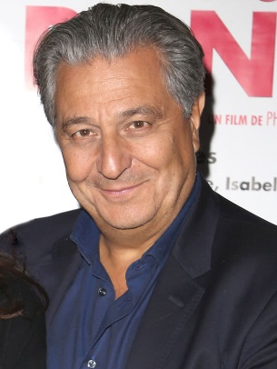 | 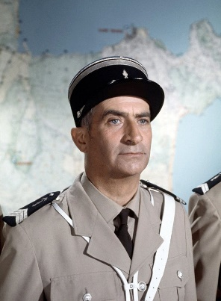 | 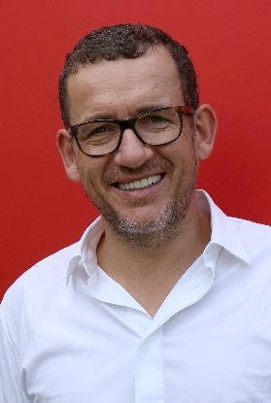 | 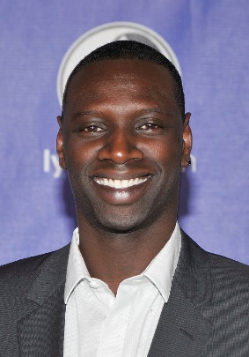
Brigitte  Bardot | Christian  Clavier | Louis  de Funès | Dany  Boon | Omar  Sy

Here is the list of the 10 most successful French films of all time in France (M= Millions):
- Bienvenue chez les Ch’tis (starring Dany Boon and Kad Merad) (20.5 M tickets sold)
- Intouchables (starring Omar Sy) (19.5 M tickets sold)
- La grande vadrouille (starring Louis de Funès) (17.2 M tickets sold)
- Astérix & Obélix: Mission Cléopâtre (starring Christian Clavier and Gérard Depardieu)
(14.5 M tickets sold)
- Les visiteurs (starring Christian Clavier and Jean Reno) (13.7 M tickets sold)
- Le petit monde de Don Camillo (starring Fernandel) (12.7 M tickets sold)
- Qu’est-ce qu’on a fait au bon Dieu ? (starring Christian Clavier) (12.3 M tickets sold)
- Le corniaud (starring Bourvil and Louis de Funès) ( 11.7 M tickets sold)
- Les bronzés 3 : amis pour la vie (starring Christian Clavier) (10.4 M tickets sold)
- Taxi 2 (starring Marion Cotillard) (10.3 M tickets sold)

- Famous singers (= chanteurs et chanteuses):

(click on the links to watch their most famous songs / music videos)

Claude François : https://www.youtube.com/watch?v=WfuIrICmZWg
Vanessa Paradis : https://www.youtube.com/watch?v=Ulay2FvUEd8
Johnny Hallyday : https://www.youtube.com/watch?v=s3O1Xro7oAI
Mylène Farmer : https://www.youtube.com/watch?v=d03wJOgoq1k
Pascal Obispo : https://www.youtube.com/watch?v=2GZxqT7o8jc
Kendji Girac : https://www.youtube.com/watch?v=FndmvPkI1Ms
Louane : https://www.youtube.com/watch?v=yleB8fUXudw
Matt Pokora : https://www.youtube.com/watch?v=q2_9gcvSSmk
Maître Gims : https://www.youtube.com/watch?v=rMltoD1jCGI
Christine and the Queens : https://www.youtube.com/watch?v=rs40yxHjTxQ
Stromae (Belgian) : https://www.youtube.com/watch?v=oiKj0Z_Xnjc
Julien Doré : https://www.youtube.com/watch?v=Zqn41lMIGg8
Angèle : https://www.youtube.com/watch?v=XqAiGeEzctQ
Clara Luciani : https://www.youtube.com/watch?v=85m-Qgo9_nE
Aya Nakamura: https://www.youtube.com/watch?v=iPGgnzc34tY
Vianney: https://www.youtube.com/watch?v=eLYyCFuPCX8
Indochine: https://www.youtube.com/watch?v=KAOmC5qT02w
Patrick Bruel: https://www.youtube.com/watch?v=-_T41pMbgWA
Céline Dion (Canadian): https://www.youtube.com/watch?v=AzaTyxMduH4
Jean-Jacques Goldman : https://www.youtube.com/watch?v=493R05ifNsI
Claudio Capéo : https://www.youtube.com/watch?v=Y9GCM9DZUJo
- Famous sportsmen (= sportifs et sportives):
Thierry Henry (football)
Zinédine Zidane a.k.a. ‘Zizou’ (football)
Kylian Mbappé (football)
Paul Pogba (football)
Amandine Henry (football)
Antoine Griezmann (football)
Olivier Giroud (football)
Amélie Mauresmo (tennis). Used to be Andy Murray’s coach.
Gaël Monfils (tennis)
Jo-Wilfried Tsonga (tennis)
Florent Manaudou (swimming)
Laure Manaudou (swimming). Florent Manaudou’s older sister.
Teddy Riner (judo)
Sébastien Chabal (rugby)
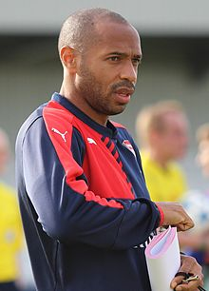 | 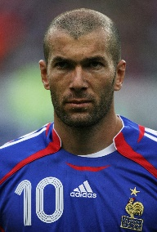 | 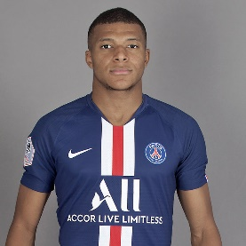 | 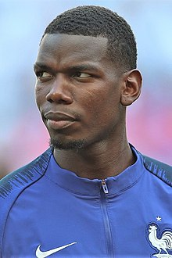 | 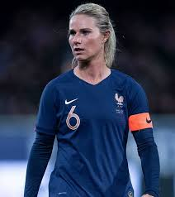 | 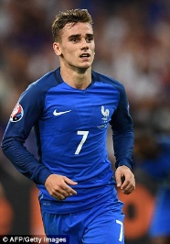 | 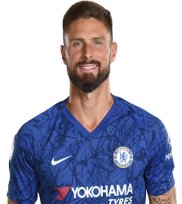
Thierry Henry | Zinédine Zidane | Kylian Mbappé | Paul Pogba | Amandine Henry | Antoine Griezmann | Olivier Giroud
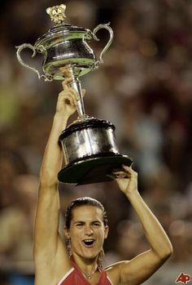 | 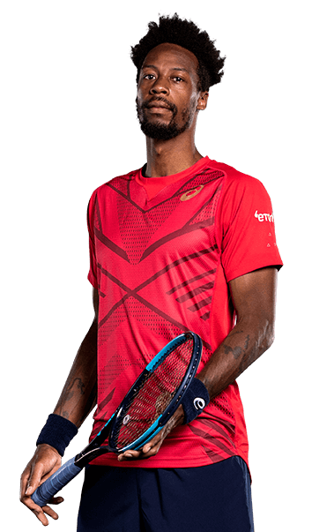 | 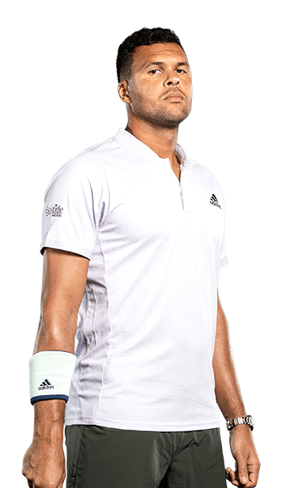 | 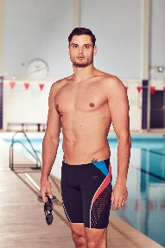 | 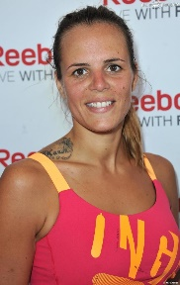 |  | 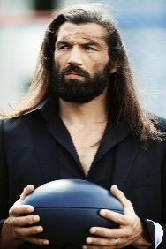
Amélie Mauresmo | Gaël Monfils | Jo-Wilfried Tsonga | Florent Manaudou | Laure Manaudou | Teddy Riner | Sébastien Chabal

- Famous scientists (= scientifiques):

Antoine Lavoisier (who put together the first extensive list of chemical elements, and helped to reform chemical nomenclature).
Pierre and Marie Curie (radioactivity).
Louis Pasteur (who created the first vaccines for rabies and pasteurization).

- Famous French Presidents (= présidents de la République) :
Charles de Gaulle, Georges Pompidou, Valéry Giscard d’Estaing, François Mitterrand, Jacques Chirac, Nicolas Sarkozy, François Hollande, Emmanuel Macron (= current President).

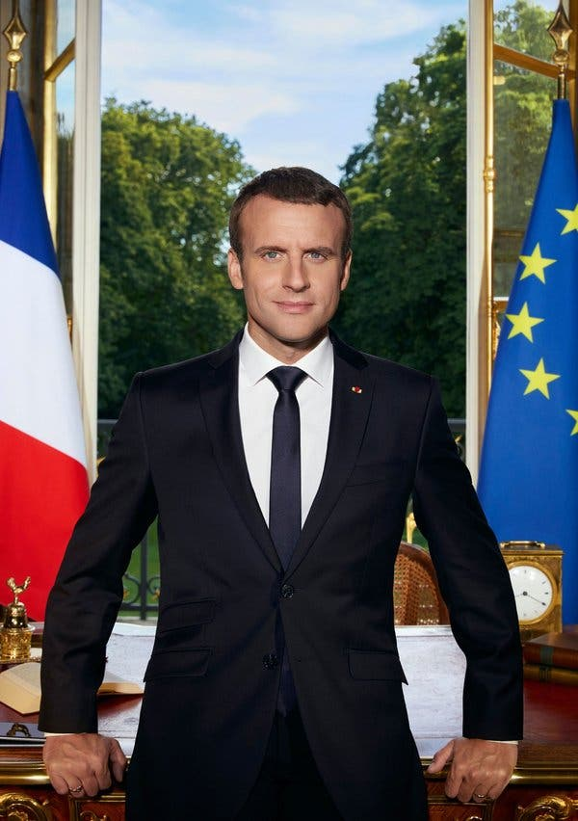 Emmanuel MACRON

- Famous writers (= écrivains):

Victor Hugo who wrote « Les misérables » and «Notre-Dame de Paris» (The Hunchback of Notre-Dame)
Jules Verne who wrote “Le tour du monde en 80 jours” (Around the World in 80 Days ) and “20 000 lieues sous les mers” (Twenty Thousand Leagues Under The Sea).
Molière who wrote the theatre play “L’avare” (The Miser) and is the equivalent of Shakespeare in France).
Jean de la Fontaine who collected and adapted famous fables into French free verse. He wrote “Le corbeau et le renard” (The Crow and the Fox) and “ Le lièvre et la tortue” (The Tortoise and the Hare).
Charles Perrault who wrote « Le petit chaperon rouge » (Little Red Riding Hood), « Cendrillon » (Cinderella), « Le chat botté » (Puss In Boots) and « La Belle au bois dormant » (The Sleeping Beauty) among other fairy tales.
Antoine de Saint-Exupéry who wrote « Le petit Prince » (The Little Prince).
Marcel Proust who wrote « À la recherche du temps perdu » (In Search of Lost Time).
Simone de Beauvoir who wrote « L’invitée » (She Came to Stay) and was in a relationship with French philosopher Jean-Paul Sartre.

Good luck and may the best student win!

