Compass Points in French

1 - Draw a line from the English word to the French word that matches it.

English North South East West

French ouest est sud nord

2 - Mark all the compass points in French on to the diagram below.

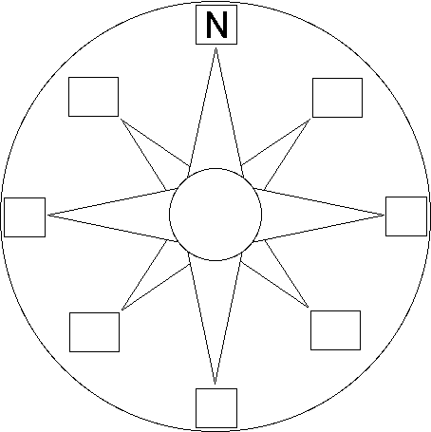

3 - Practise writing, spelling, reading and saying the points in French below.
ouest est sud nord
____ ____ ____ ______
____ ____ ____ ______
____ ____ ____ ______
____ ____ ____ ______

Compass Points in French

1 - Unscramble the words to spell them correctly and then draw a line from the English word to the French word that matches it.

English htnro htous stae tsew

French etsou tse dus dorn

2 - Mark all the compass points in French on to the diagram below.

3 - Practise writing, spelling, reading and saying the points in French below.
____ ____ ____ ______
____ ____ ____ ______
____ ____ ____ ______
____ ____ ____ ______

