French Food
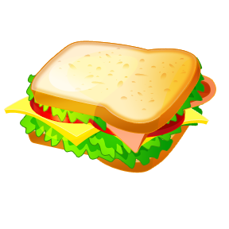

- Write the letter from the menu in the corresponding box.
Le Menu
- Un lait frappé
- Un hamburger
- Des frites
- La soupe et du pain
- Un sandwich
- Œufs et du bacon
- Spaghetti
- La crème glacé

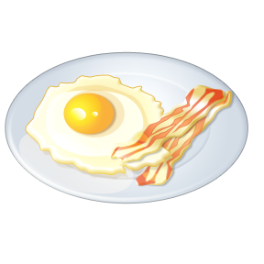

- Write a short paragraph describing what you had for dinner from the menu above. It can be made up, or real.
Je mangé…
________________________________________________________________________________________________________________________________________________________________________________________________________________________________________________________________
- Describe your imaginary meal, mixing different foods together, and draw a picture.
__________________________________________________________________________________________________________________________________________________________________________
Mon repas imaginaire est…

