Name: ___________________

Year 5 keyboard quiz

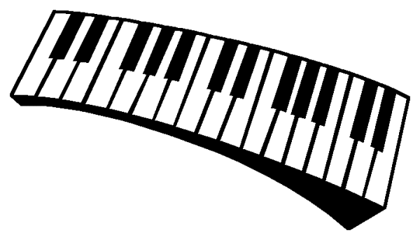
- Put the correct letter names on the white notes.
- Now put the names of the black notes on using the lines that have been drawn for you.
- Which hand should you use to play tunes? Left or right? ______
- If you are playing a piece that only has the notes C,D,E,F and G, which fingers should you use for each note? C_________, D___________, E___________, F_____________, G_____________
- What is this sign called: #__________ ? And this one: b_________?
- What do these signs mean when they are put next to a note e.g. C#?
# means__________________ b means ___________________

