 | Trumpet
 | Trombone
 | Glockenspiel
 | French Horn
 | Timpani Drum
 | Drum
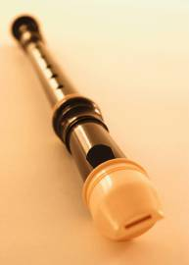 | Recorder
 | Oboe
 | Violin
 | Cello
 | Harp
 | Viola
 | Piano
 | Saxophone
 | Guitar
 | Drum
 | Acoustic Guitar
 | Electric Guitar
 | Violin
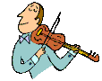 | Violin
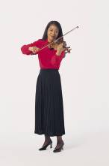 | Violin
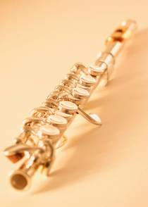 | Flute
 | Flute
 | Tuba
 | Bongo Drums
 | Bongo Drums
 | Saxophone
 | Piano
 | Piano
 | Piano
 | French Horn

www.jamesstarbuck.com

Print out, fold and laminate into cards. The children can use them for many activities including matching them into the orchestral families.

