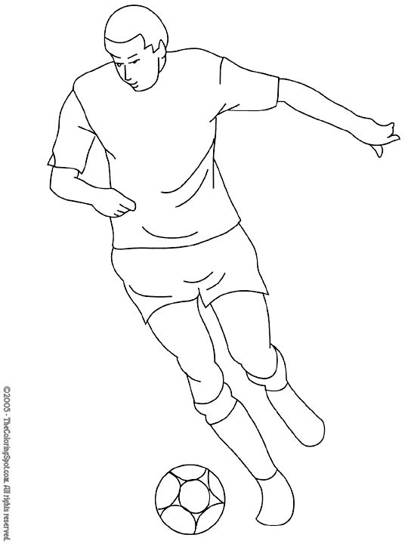

My World Cup Team
By ____________________

Country: _______________________________________

Flag: .--Home strip:

Continent: __________________________

Capital City: ________________________

Language: __________________________

Currency: _______________________

Five interesting facts about my country:

1. _____________________________________________________

2. _____________________________________________________

3. _____________________________________________________

4. _____________________________________________________

5. _____________________________________________________

