Daily Timetable

Lunch

Break time

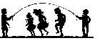

Guided Reading

Registration

Spellings/
Times tables


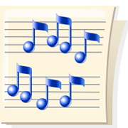
Music

Physical Education

ICT


Circle time

Assembly

Geography

History



SEAL

Art

Design & Technology

Literacy

Numeracy
Science
Handwriting
Religious Education

