Numeracy + =

Literacy

Science

Art

PE

History

Geography

RE

ICT

D&T

Playtime 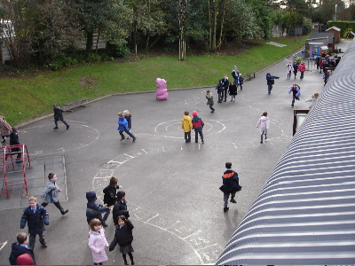

Lunchtime

Reading w/Y2

Home Time

Library

Circle Time 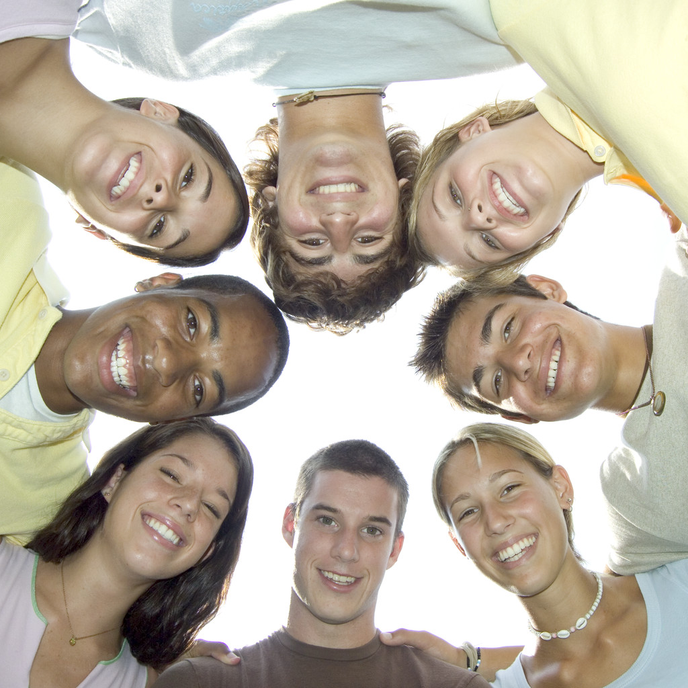

Music

Assembly

PSHE 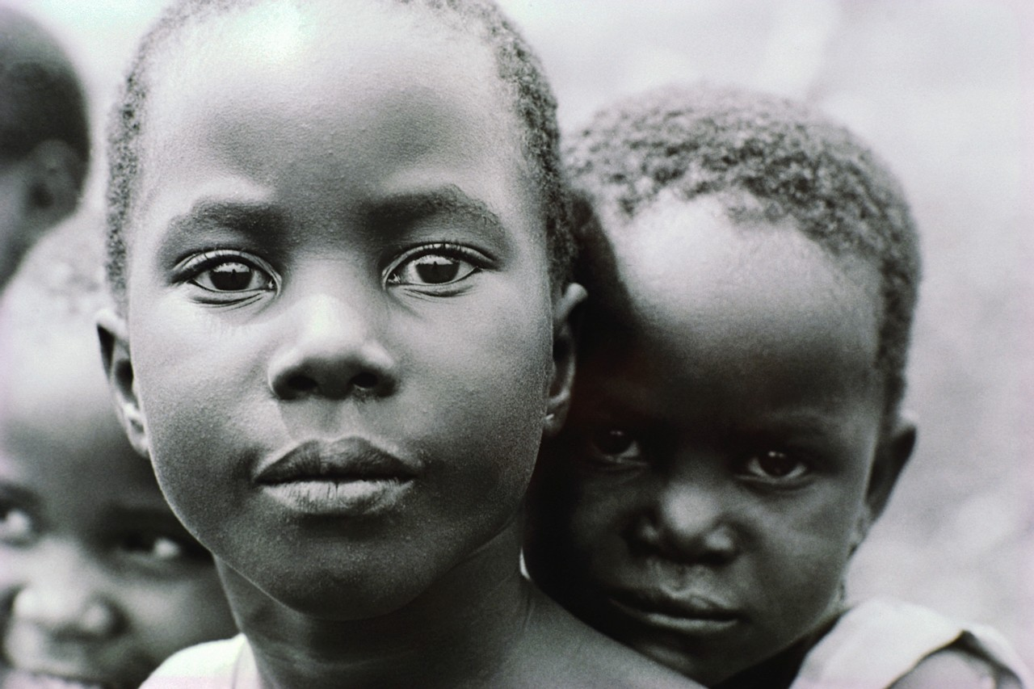

French 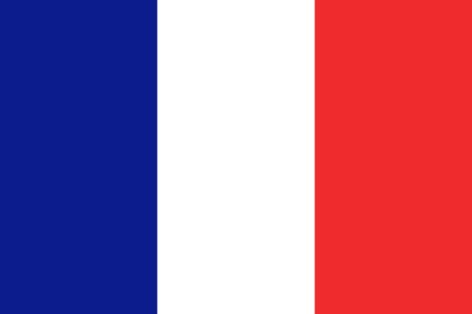

German 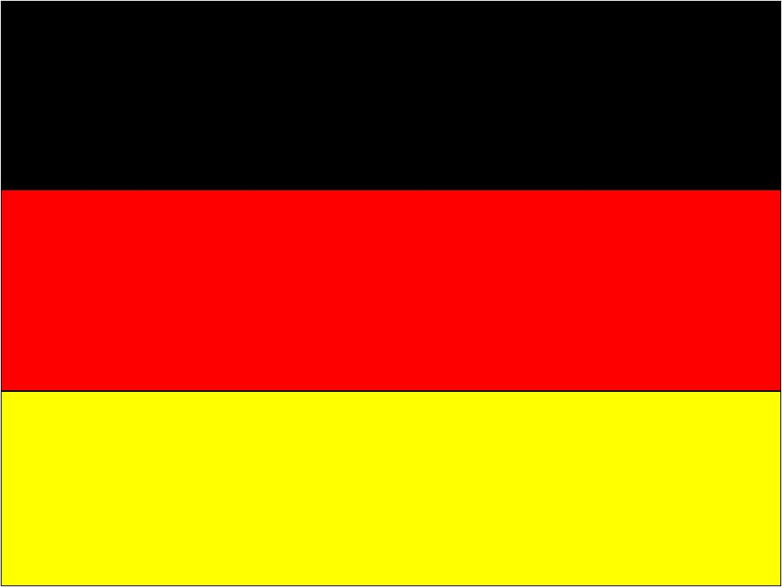

Greek 

Spellings A B C

