Catchball
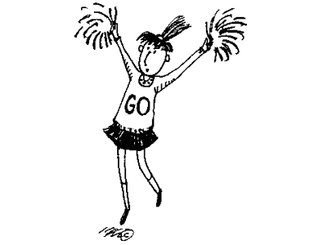
How to play

The Game
Catchball is played on a court that:
- Is divided into thirds;
- Has a semi- circle marked at each end;
- Contains a hoop inside each semi-circle;
- Has a centre circle.
The game is played with two teams of 7 players. One player from each team stands in the hoop at the opposite end of his / her team.

NB: Catchball is a good introduction to the game of Netball for younger children. Many of the rules of Netball apply to Catchball.

Aim
The aim of the game is to score more goals than the opposition.

Starting play
Play starts with a pass from the centre circle by one player, passing back to a player on his / her team on hearing the umpires whistle. Each team must stand behind the line, inside their defending third (not inside the centre third) until the whistle is blown.

Scoring
A goal is scored by the player inside the hoop catching the ball without stepping outside the hoop. Once a goal is scored the game restarts with a centre pass. Centre passes are alternate between the teams. The only players allowed inside the semi-circles are Hoop-player and two defenders. The attacking team may not enter their attacking semi-circle.

Rules
- Players must not move with the ball;
- Players have 5 seconds to pass the ball;
- No contact of the player should be made during play;
- A player needs to be a metre away from the player holding the ball;
- A player may not mark another player using their arms – they should use their body only;
- If a player, moves with the ball / takes longer than 5 seconds to pass, the other team take a free pass (umpires do not call ‘play’);
- If a player, stands too close to a player holding a ball / contacts another player, the other team take a free pass and the offending player must stand beside the player taking the free pass until the ball is thrown and they can rejoin play (umpires do not call ‘play’);
- When a ball is knocked out of play via the side lines a side-line pass is taken by the other team (umpires do not call ‘play’);
- When a ball is knocked out of play via the back lines a back-line pass is taken by the other team (umpires do not call ‘play’);
- When a defender knocks the ball out of play in the semi-circle the attacking team take a pass from the back line outside the semi-circle (umpires do not call ‘play’);
- The only players allowed inside the semi-circle are the Hoop-player and two defenders;
- The attacking team players may not enter their attacking semi-circle;
- If the Hoop-player steps outside the hoop the other team take a back-line pass.
