Mushroom
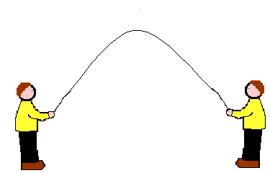
This is a basic starting point for parachute games. Get everyone to spread out evenly around the chute and hold the edge. Pull the chute taut and crouch down. On the command MUSHROOM, everyone stands and pulls the chute upwards causing the chute to fill with air and rise like a giant mushroom.
Mushroom Variations
Everyone MUSHROOMS, then lets go.
Everyone MUSHROOMS, takes one step in, sits down pulling the chute behind them, so everyone is sitting in a TENT.
Everyone MUSHROOMS, then runs to the centre, still holding the chute.
Tent Pole
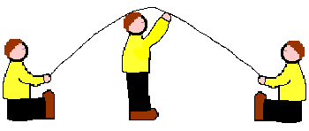
While you're in the tent, try this: One person is selected to be a tent pole and stands in the middle, holding the centre of the chute as high as possible. The tent-pole person calls out someone's name and goes and sits down in that person's place. The person called has to rush to the middle and take up the role of the tent-pole before the chute comes down. Repeat the procedure as long as you feel like it.
There's also a variation of Tent-Pole, which is called Jellyfish. In this version, all the seated people sway about as much as possible for the tent-pole to stay upright. From the outside, the chute should look like a gigantic quivering jellyfish.
Upside-down tent
An alternative way to make a tent is to have everyone lie on their backs under the chute, heads to the middle with their feet up in the air. Stretch the chute tight and tuck the chute under your backs so it holds your legs up. You can bring in a soft ball and use your hands to bounce it around inside the tent.
Air Conditioning
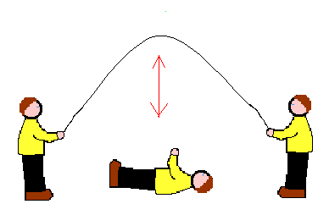
This game is good for recuperation after an energetic game. Hold the chute stretched out and have about a third of the people lie on the ground under it (best with heads near the middle). The rest mushroom the chute up and quickly pull it down again repeatedly.
Air rushing in and out cools those underneath like a giant fan, and the sensation of watching the chute rise up and then come down on top of you is very strange.
The Ocean - suggested by Amy Chartier
We pretend the parachute is the ocean. I have them give me the name of an ocean. Children move the parachute in response to the 'weather report' they heard. (Encourages children to be creative). For example, I'll say, "I heard on the weather report this morning that there was a slight breeze over the Atlantic. What would that look like?" The children respond by making small waves in the parachute. Other suggestions have been - high winds, snow (we would have to pull it tight to make the ice), twisters, etc. Once they get the hang of it the possibilities are endless.

Parachute Ball Games
Most of these games can be played with balls of different kinds: Tennis balls; footballs; beach balls; and even a giant earth ball. Different sized balls will change the way in which the game goes, so feel free to experiment.
Chute Ball
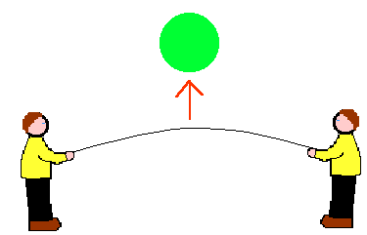
This game is best played with an earthball (a large beach ball). You simply place the ball in the middle of the chute and by pulling upwards and outwards, throw the ball as high in the air as possible. This game can also be played by replacing the ball with a small child or doll.
Competitive chute ball
Mark a line across the diameter of the chute. Have equal teams hold the edge of the chute on either side. Throw a ball into the middle. The aim is to get the ball off the chute on the other team's side of the line, and stop it coming off your own side of the line. (i.e. to throw it over the other team's heads). You mustn't let go of the chute or touch the ball with any part of the body. Keeping score is optional.
After several minutes of wild flapping and little progress the group should realise that co-ordination and strategy are needed to flick the ball off the chute.
Popcorn
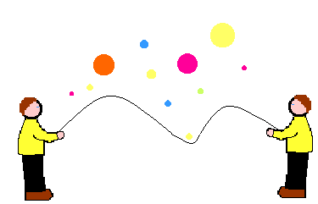
Start with everybody holding the chute streched out. Throw as many soft balls as you can find on to the chute. Then see how quickly you can bounce them off with out letting go of the chute. Alternatively you can have half of the children trying to bounce the balls off and half trying to keep them on.
Bouncing balls
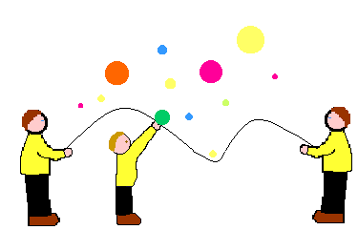
Start as above and this time have two or three children under the chute. The children under the chute have to try and push off the balls while every one else tries to keep them bouncing.
Rollerball
Everyone holds the chute taut. Place a large ball near the edge. Try to make the ball roll around the edge of the chute. To do this, someone starts the ball rolling. As it comes towards you, you lower the edge you are holding, and as it goes past you raise your edge. When all the players do this in synchronisation, it creates a kind of wave going round the edge of the chute which pushes the ball in a smooth steady circle. It can not be done without concentration and co-operation, but it is very rewarding for a group to eventually achieve the correct motion. Once you have mastered the correct motion try changing the direction or speeding up.
Change Over
MUSHROOM the chute and call out a command, e.g. "Change over if you are wearing red". Everyone wearing red has to run under the chute to the opposite side, before the chute lands on them (although that is part of the fun).
Musicless Chairs
Number the children by threes around the chute, so that you have an equal number of ones, twos and threes evenly spread out. Mushroom the chute, then call out a number and also a description of who you would like them to act as.
For example, if you call out: "Mushroom... Number ones are ballerinas", all of the number ones have to cross under the chute, acting like ballerinas on the way
Jaws
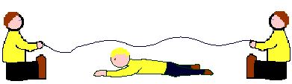
Everyone should sit on the floor in a circle, holding the parachute stretched out with their legs underneath it. The chute is the sea, and the children are all sitting on the beach, happily dipping their toes in the water. By shaking the edge of the chute, you will produce a realistic rippling wave effect.
Once the waves are going well, choose someone to be the shark, and tell them to disappear under the chute. They should move around underneath, and because of the waves, it is difficult to know where they are. The shark chooses a victim and grabs them by the feet. The victim will then let out a scream and disappear under the chute. The new person then becomes a shark. The old shark can become a bather, or continue being a shark (depending on the teacher's decision).
Cat and Mouse
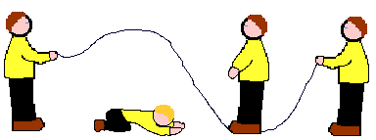
Everyone should stand in a circle holding the chute stretched out at about waist height. Someone becomes a mouse and goes underneath. Someone else becomes a cat and goes on top. The cat tries to catch the mouse, but with everyone billowing the chute, it is impossible to see where it is.
Every now and then you can give the cat a clue by lowering the chute to reveal the mouse, then raise it again to help the mouse get away. You can try the game with two or three mice and two or three cats.

