Task 1-Animal Farm

Set pupils out in the area spaced out.

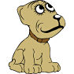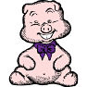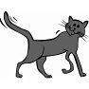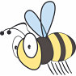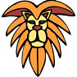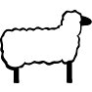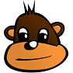

Pupils then blindfolded, try to find each other through sound.
Alt; pupils are given animals randomly, so don’t know who matches. They must (not blindfolded) try to find their match.

Task 2-Bench Game

Pupils line up on the bench, they are then given an order which they must get into on top of the bench without touching the floor;

- Tallest to shortest
- Date of birth
- Size of feet
- Alphabetically by name

This can be made more difficult by not allowing pupils to communicate through speech

Task 3-Rope Shapes

Start
Pupils wearing blindfolds

Pupil giving instructions

Finish
Task 4-Human Bridge

Pupils in a team are set the challenge of going as far as they can from the wall, by only allowing the pupils to use a certain number of body parts;

6 hands, 3 feet, 4 bottoms, 3 knees

Pupils must stay in contact with each other and one of them in contact with the wall

Task 5-Magic Carpet

Start Finish

Pupil must move the mat between the start-finish lines, WITHOUT anyone touching the floor.

This can be done racing with another team.

It can be made more difficult by having more pupils or a smaller mat.

Task 6-Minefield

Pupils must cross the mine field by finding the safe route across. The game is timed, and pupils are not allowed to communicate with each other, they must rely on their memories.

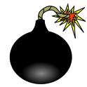 |  | Safe
Safe
 | Safe |  | Safe | Safe
 |  |  |  |  | Safe

This can be made easier by allowing pupil to communicate in a fashion suggested by the teacher.
Task 7-Roundabout/Hoop

Pupils stand in a circle with hands linked, a hoop is placed in the circle at some point and the pupils have to move the hoop round the circle without breaking the links as quick as possible.

Task 8-Roundabout Two

Pupils sit with their arms crossed and hold onto the wrist of person next to them. They must all face the centre of the circle and try to stand up together.

Task 9-Skipping Game

Pupils start in a line, and must pass under the skipping rope first one at a time, then in pairs, in 4’s, 8’s and so on…

Pupils will need to go under the rope together in order to be successful. Ensure that pupils are far enough back before the game starts.

Pupils can see how they can get from their team to jump the rope at the same time, this can be the extension exercise.
Task 10-Stand Up

Pupils will start sitting back to back, they must then link arms and try to stand up
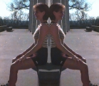

Task 11-Whistle Game

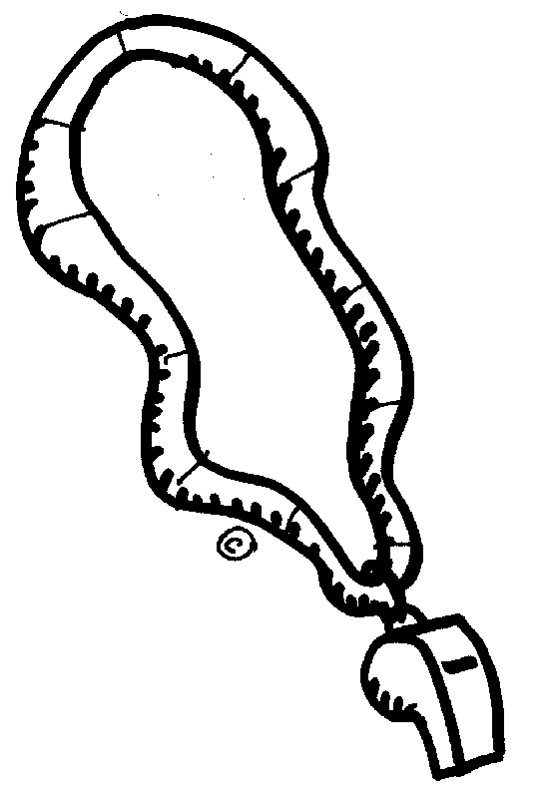

Pupils must work together to blow the whistles, however they must not touch any of the whistles by hand, and all whistles should be out of reach to the tallest of the pupils.

Task 12-Trust Circle

The pupil in the centre allows themselves to fall in any direction, the remaining members of the team use their hands to ensure they don’t fall out.

Pupil in the centre could be blindfolded.

Pupils around the outside should be stood with one foot behind to give themselves maximum stability.

Task 13-Sit Down

Pupils start in a circle and must sit down on one of the teams knees without breaking the circle, and they may only touch the floor with their feet.

Task 14-Leap Frog

Pupils must swap sides so all green and yellows end up on opposite sides. They must follow these simple rules;
- They can only move forwards
- They may only move one at a time
- They can only jump one person at a time.

