16th January 2014
I can tell you some things about me that have changed and some things that will not change.


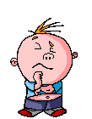
Some things about me that have changed are…
Some things about me that will not change are…

