What are you planning to do over your summer holiday?

______________________________________________________________________________________________________________________________________________________________________________________________________________________________________________________________________________________________________________________________________________________________________________________________________________________________________________________________________________
A Little About Me......

Name ___________________________

What makes you happy?
______________________________________________________________________________________________________________________________________________________________________________________________________

What makes you sad?
_______________________________________________________________________________________________________________________________________________________________________________________________________________________________________
What is your family like? (do you have any brothers and sisters?)
_____________________________________________________________________________________________________________________________________________________________________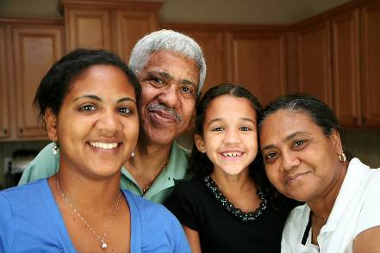

Do you have any pets? If so describe them.
______________________________________________________________________________________________________________________________________________________________________________________________________
What has been your favourite subject so far and why?
______________________________________________________________________________________________________________________________________________________________________________________________________
_________________________________
Which subjects do you think you need the most help in?
_____________________________________________________________________________________________________________________________________________________________________
What are you looking forward to doing in Year 6?
_________________________________________________________________________________________________________________________________________________________________________________________________________________________________________________________________________________________________________
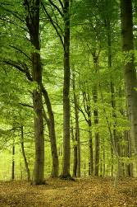
____________________________________________________________________________________________________________________________________
Is there anything you are worried about, going into
Year 6? __________________________________________________________________________________________________________________________________________________________________________________________________________________________________________________________________________________________________________________________________________________________________________________________________________________
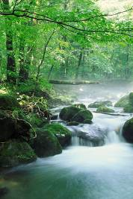
I am special because..............
_________________________________________________________________________________________________________________________________________________________________________________________________________________________________________________________________________________________________________
My hobbies are.........
____________________________________________________________________________________________________________________________________
In my spare time I like to ........



