A Jewish Wedding

As a follow up to watching ‘A Jewish Wedding’, each child made their own Ketubah (a Jewish marriage contract) by cutting out a patterned border on white A4 paper and writing their own promises in the middle. They were then mounted on coloured paper. Two examples are shown below.
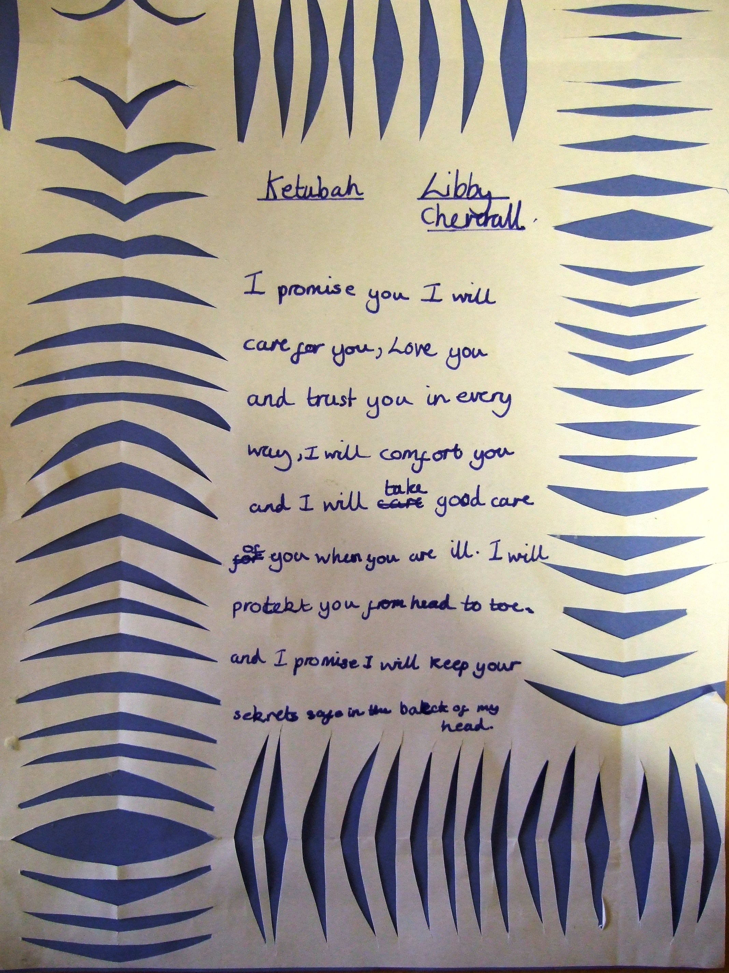
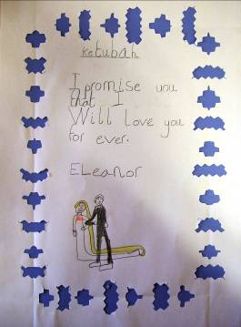

Eleanor Y3 Liberty Y4

