Theme: Chinese New Year 2016, Year of the Monkey
For Grades 2, 3, and 4

Lesson 1
Introduction

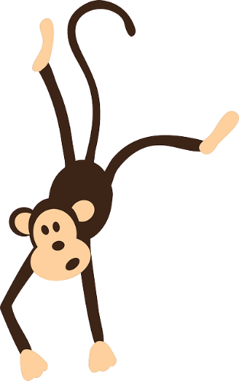
Chinese New Year is the most important festival of the year for Chinese families. It is a time when families get together. Many family members travel long distances to gather with their families in China, Hong Kong, and other parts of the world. Homes, villages, and towns are decorated in red and gold. The red and gold colors together symbolize good fortune, joy, and the center of everything.

Each year is associated with a different animal from the Chinese zodiac. The year 2016 is the Year of the Monkey.

CC0 Public Domain

Discuss suggested vocabulary to be used and heard during the lesson.
Teachers may wish to add additional words to the list.

Vocabulary list suggestions
zodiac | origin
legend | Buddha
reward | emerge
represent | present
prosperity | symbolize
name | paste
founder | religion
population | capital city

Geography: China is the biggest country in Asia and has the largest population in the world. The capital city of China is Beijing. Where in the world is China? Students to find China on a world map.

The Chinese Zodiac
The origin of the 12 signs

The 12 animals found in the zodiac are derived from a legend. The legend explains that Buddha, the founder of the Buddhist religion, invited all the animals to join him on New Year's Day. Only 12 animals did so. Buddha named a year after each animal who joined him. The animals arrived in the following order: rat, ox, tiger, rabbit, dragon, snake, horse, sheep, monkey, rooster, dog, and pig. The rat sat on the back of the ox, jumped off just before they arrived, and therefore was first. Had the rat not done this the ox would have been first.

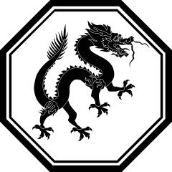

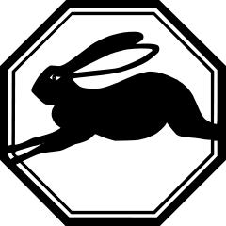

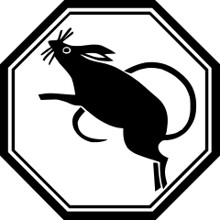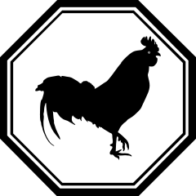
Public domain

Cut out each animal.
Paste them here in order of their arrival.

Lesson 2
Calendars

A calendar is a system of planned events or a form of time keeping. Seven days make up a week, about four weeks make up a month, and 12 months make up a year. Every year has a number, such as 2016 or 2017.

Discuss suggested vocabulary to be used and heard during the lesson.
Teachers may wish to add additional words to the list.

Vocabulary list suggestions
calendar | system
lunar | different
solar | lunisolar
Gregorian | cycle

Science: There are many types of calendars? What do we mean by lunar, solar, and lunisolar calendars?

The lunar (moon) calendar is based on the movement of the moon around the Earth, which takes about 29.5 days. Because the number of lunar cycles in a year (12-1/3) is different than the number of months in a year (12), Chinese New Year falls on a different date each year.

By http://clipartcotttage.deviantart.com/, CC BY 3.0

The solar (sun) calendar is divided into 12 months, and every fourth year is a leap year, a year that has an extra day in it. New Year’s Day is always celebrated on the first of January. The solar calendar is also known as the Gregorian, Western, or Christian calendar.

Public domain

The lunisolar calendar is a combination of the lunar and solar calendars. Also called the Lunisolar calendar. Chinese and other Asian communities across the world use the lunisolar calendar, and Chinese New Year is based on the lunisolar calendar.

Lesson 3
Lantern Festival

Discuss suggested vocabulary to be used and heard during the lesson.
Teachers may wish to add additional words to the list.

Vocabulary list suggestions
festival | parade
celebrate | family affair
lantern | lotus flower
tradition | silk
materials

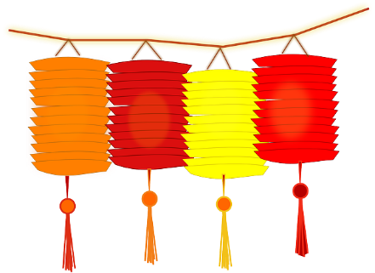
Chinese New Year usually starts with the new moon on the first day of the new year and ends on the full moon 15 days later. The 15th day of the New Year is called the Lantern Festival. The festival is celebrated at night with lantern displays and children carrying lanterns in a parade. New Year’s Eve and New Year’s Day are celebrated as a family affair, a time of being together and a time of thanksgiving.

CC0 Public Domain

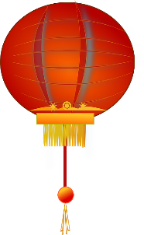
The Lantern Festival is very colorful. Thousands of lanterns are hung around towns, cities, homes, and stores. The festival marks the end of Chinese New Year. Each lantern color has a different meaning. Families hang red lanterns to indicate joy and happiness. White lanterns indicate that a family member died. Many years ago lanterns traditionally were made from silk, paper, or glass, and in different sizes and shapes. Lanterns today are made out of a variety of materials. Many take on the shape of an animal, a lotus flower, or even a box.

CC0 Public Domain

Lesson 4
Customs and Traditions

Chinese New Year customs and traditions are still upheld by many families today. The whole house and all items in the house are cleaned before New Year’s Day. On New Year’s Eve, families ensure that all brooms, dusters, dust pans, and cleaning items are put away. No cleaning or sweeping is done on New Year’s Day, as it is believed that doing so would sweep away all good fortune.
CC BY-SA 3.0

After New Year’s Day, there is a particular way in which cleaning is continued. One sweeps all dust and rubbish from the front door area to the middle of the room. The dirt is then picked up, placed in the corners of the room, and not taken out until the fifth day after New Year’s Day. Everyone in the house ensures not to step on the rubbish left in the corners. On the fifth day, dirt is picked up and taken out through the back door because there is a belief that all good fortune and a family member will be swept away if dirt is swept out through the front door.

Discuss suggested vocabulary to be used and heard during the lesson.
Teachers may wish to add additional words to the list.

Vocabulary list suggestions
items | good fortune
particular | rubbish
removed | debt
create | future
new beginning | lai see packet
compartment

Tradition recommends that people pay off all their debts before New Year’s Day so they can start the new year by owing no money to anyone.
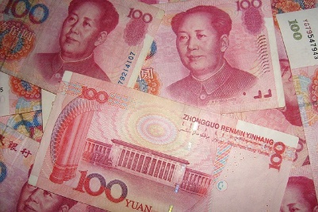
CC0 Public Domain

People have to ensure that they use no foul language, negative terms, or the word Chinese word for the number “4”, which sounds like the Chinese word for “death”. People should also not talk about death or dying and should not tell ghost stories. They should speak not of the past, but instead only of the future, as their attention should be focused on the new year and new beginnings.

People should not cry on New Year’s Day, as it will create a future filled with tears. For that reason, children are not given hidings at that time, as parents do not want their children to cry throughout the new year.

Washing of hair on New Year's Day is not recommended, for doing so will wash away all good luck. Red clothing is worn, as it is considered a bright and happy color that brings joy and good fortune for the rest of the year.

Millions of new bank notes (Chinese currency) are printed before Chinese New Year. The new bank notes are inserted into little red packets called lai see. Lai see packets are given to any of the following: elders, young people who have no income, one’s own children, employees, and unmarried friends. The packets’ red color symbolizes good luck. The purpose of the packets is to bring good fortune, blessings, and happiness to the recipients. It is impolite to open a lai see packet in front of the person who gives it to you.
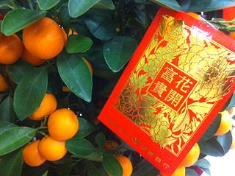
Poa Mosyuen, CC BY-SA 3.0

During Chinese New Year, Chinese homes are brightly decorated. Living rooms are filled with pretty blossoms and have fruit platters that contain oranges and tangerines. Blooming plants and flowers symbolically represent wealth, new growth, and rebirth, especially in one’s career. When one buys a new plant and it blooms on New Year’s Day, that foretells a year of prosperity. It is very lucky when this happens. Peonies and water lilies are very popular flowers. Oranges and tangerines on fruit platters symbolize abundant happiness. When visiting family or friends over this period it is regarded as good etiquette to bring to your hosts oranges and lemons that still have leaves attached.

Lesson 5
Traditional New Year Foods

A candy tray is traditionally used at Chinese New Year, as it represents good fortune. It is usually shaped in a circle or octagon and has different compartments. It is shared and enjoyed with family members and friends when they arrive at gatherings. Types of candies found on the tray include: candied melon, red melon seed, lychee nuts, kumquats, coconut, peanuts, longan fruit, and lotus seeds. Each of these brings a particular blessing into one’s life. Candied melon brings growth and good health; melon seeds dyed red are symbolic of joy and happiness; lychee nuts build strong family relationships; kumquats have a lovely golden color that represents prosperity; coconut equals togetherness; peanuts bring long life; longan, also called Dragon Eye, is sweet like a lychee and will bring many good sons; and lotus seeds will bless families with many children.
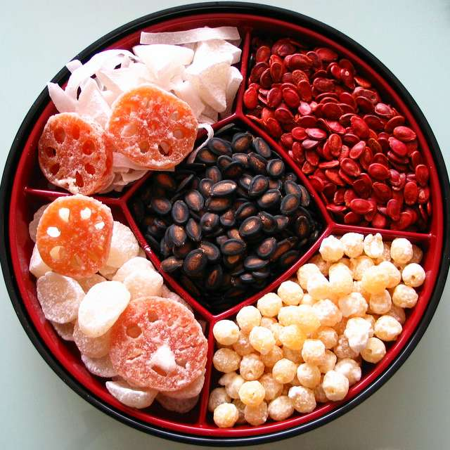
Denise Chain, CC BY-SA 2.0

New Year is a time of year when traditional food is cooked to feed family and friends. Food is also put out for family members who have died. A popular vegetarian dish eaten at this time is called jai. Jai is a sweet pastry or dumpling filled with peanuts, coconut, and sesame seeds. Each dumpling is shaped like a moon and is a sign of good fortune, as the moon shape is suggestive of traditional Chinese currency. Other traditional cooked foods include a whole fish and a chicken that still has its head, tail, and feet, both of which symbolize togetherness, wholeness, and completeness. Uncut noodles are also served, as they represent long life.

Lesson 6
Fifteen Days Of Celebration

Chinese New Year is celebrated over 15 days. Each day has its own particular meaning.
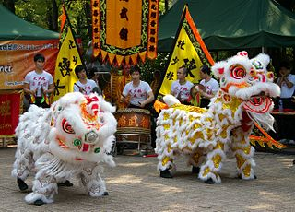
Jakub Hałun, CC BY-SA 4.0

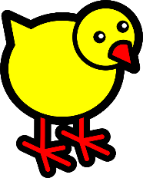
Day 1, birthday of the chicken. This is a day on which people visit their senior family members, who serve fruit treats to their visitors. On that same day, lion dances (right) can be seen on the streets.
CC0 Public Domain

Day 2, birthday of the dog. Pet dogs are fed well, given extra treats, bathed, taken for long walks, and given clean bedding. Stray animals are also fed.

It is also a day on which married women visit and pay respects to their birth parents.

CC0 Public Domain

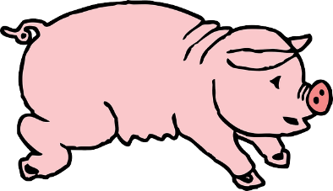
Day 3, birthday of the pig. If a family death has occurred in the past three years, family members will visit their graves. This is a way they show respect to those who died.

CC0 Public Domain

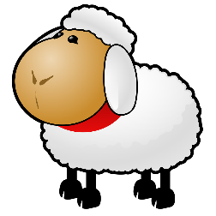
Day 4, birthday of the sheep. This day is a continuation of day 3. It also provides time that can be used to travel to and from family homes.

CC0 Public Domain

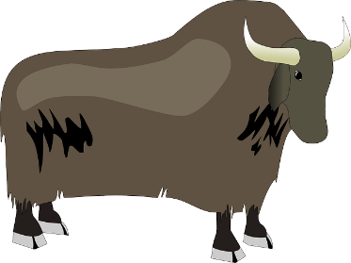
Day 5, birthday of the ox. This is also the birthday of the God of Wealth. People leave their house only if necessary in case the God of Wealth should decide to pay a visit to bless family members with wealth and good fortune. Shops therefore remain closed.

CC0 Public Domain

Day 6, birthday of the horse. A day when families and relatives visit one other. This is also a day they would go on temple visits.

CC0 Public Domain

Day 7, birthday of humans. A traditional birthday for the common man. Some pray to the Jade Emperor, one of the most important gods.

Day 9, birthday of the Jade Emperor or Lord of Heaven. Offerings to the Jade Emperor are made on this day.

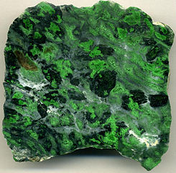
Jade is stone or rock that consists of two minerals. It is used to make ornaments, objects, and jewelry. It is very valuable. Therefore, it is usually quite expensive.

James St. John, CC BY-SA 3.0

Days 10 to 12, days of togetherness. Friends and family spend time with one another and have dinner together. A lot of rich food is eaten in celebration of being together.

Day 13, a day of cleansing. Vegetarian food is eaten to cleanse the digestive system after all the rich foods eaten over the festive period.

Day 14. Preparations for the Lantern Festival are made.
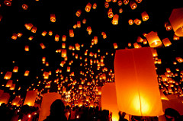
Day 15. This is the date of the first full moon after the spring festival, and another dinner is held where moon shaped dumplings are eaten. Lion dances and lanterns of various shapes and sizes are seen everywhere. In some areas, lanterns are made and set off to fly into the sky like hot air balloons. Messages are often written onto the lanterns before they are sent off.

Mark Fischer, CC BY-SA 2.0

Cross-Curricular Ideas and Activities

Science: Teach students about different foods. Some are healthy and others unhealthy, but in some cases it’s OK to eat unhealthy foods occasionally.

Technology time and science lesson: Use the Internet to get to know more about orange and lemon trees, peonies, water lilies, and popular flowers found in China.

Fun activities:
- Learn about a different culture by organizing a school outing to a Chinese restaurant to have dumplings and use chopsticks.
- Invite a Chinese family to your class to present a candy tray and lai see packets to the students. Lai see packets filled with gold chocolate coins can be an exciting treat for each student. You could also ask parents to send lai see packets with chocolate coins. Have a few extra lai see packets for any students whose parents don’t provide packets.

Literacy and art: Read a Chinese tale, “Lao Lao of Dragon Mountain” (http://www.amazon.com/Lao-Dragon-Mountain-Folk-Tales/dp/1840890118). Make a paper-cut butterfly like Lao Lao’s.

Math:
- 2-D shapes. Students draw a circle, triangle, rectangle, pentagon, hexagon, and octagon. They number the sides of each shape and write that number on the shape.
- The Chinese abacus is a simple device used to do mathematical calculations. You can use the abacus for addition, subtraction, division, and multiplication. It is fun. Find a YouTube video that shows students how to use a Chinese abacus.
- A math story problem to be solved. The 12 animals of the Chinese zodiac gathered together at the emperor’s palace to celebrate Chinese New Year. Five animals went to fetch a candy tray and some food. How many animals were left behind at the palace?
- Another problem to be solved. The following were placed onto the candy tray:4 heart-shaped candies, 6 triangle-shaped candies, 4 square candies, and 3 circle-shaped candies. How many candies were there all together?

Art/design/technology:
- Decorations. Make Chinese New Year decorations to decorate your classroom.
- Chinese lanterns. Find instructions on the Internet that will show students how to design Chinese lanterns from paper to decorate the classroom.

Exploring Chinese characters: Use ink and brushes to write “Happy New Year” in Chinese. Students can also use Chinese characters to create their own Chinese New Year decorations.

Fun activity: Sweep your classroom the same way a home is cleaned after the Chinese New Year. (See Lesson 4 above.)

Care for your dog. Be a responsible pet owner: Give your dog a bath, wash his or her bedding, take him or her for a walk, and feed your dog healthy food. Ensure to take your dog to the veterinarian when the pet becomes sick. It is important to protect our pets from being afraid or hurt by New Year fireworks.
Written task: Write about your plans for the Chinese New Year holiday. Will you spend time with family? Will you be visiting them, or will they come to your home? Will you have a celebration party? The teacher can encourage the pupils to use their imagination by writing a couple of supporting sentences on the board to guide students in their writing.
CC0 1.0 public domain

Physical education. Select one of the following popular Chinese forms of exercise (instructions and examples can be found on YouTube):
- Yoga
- Qigong

Library. Independent Reading Time: Teacher can have a book display in the classroom. Select books that represent various aspects of China. Students could be taught any of the following aspects:
- What is a fiction book?
- What is a non-fiction book?
- What is an author?
- What does an illustrator do?
- What is an illustration?
- What does the Table of Contents in a book tell us?
- Where do we find the index of a book?

Music. Two possible activities for students:
- Play traditional Chinese classical and folk music as background music in class.
- Birthdays of the week. Call students who celebrate birthdays to the front of the class while the rest of the class sings Happy Birthday. Students can also try to sing the Chinese version of Happy Birthday, which can be found on YouTube.
CC0 Public domain

Copyright 2015 by Maria Elizabeth Lotter

