Let my people go!

God turned the rivers to _______________.  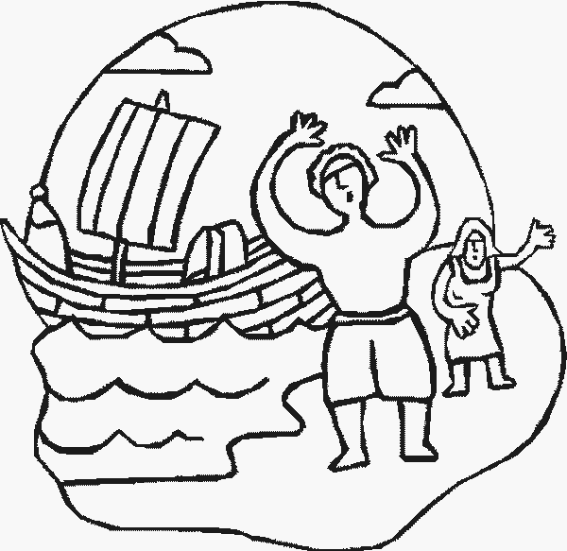  But Pharaoh said, ‘_______’. | God sent a plague of _____________.  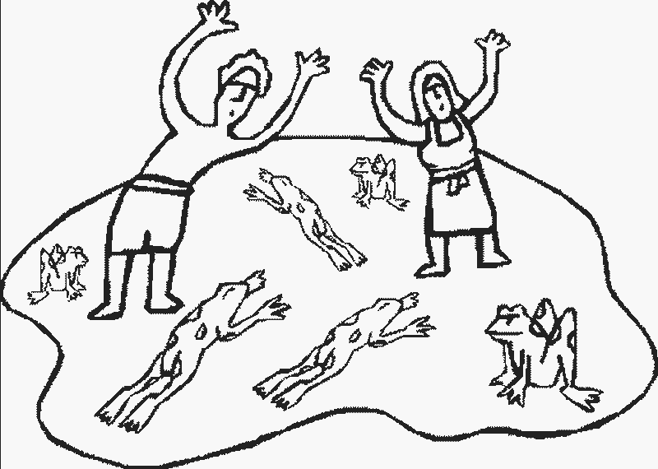  But Pharaoh said, ‘________’.
God sent a plague of ____________.  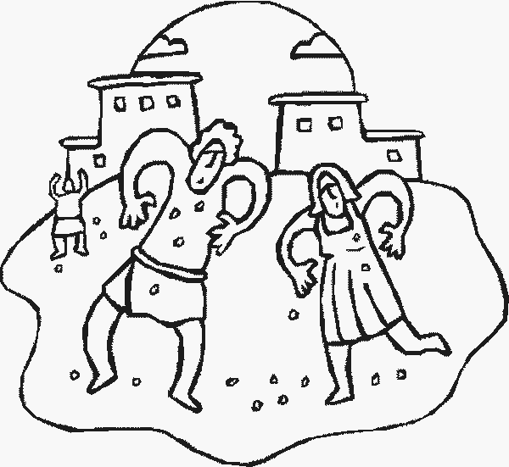  But Pharaoh said, ‘_________’. | God sent a plague of _____________.  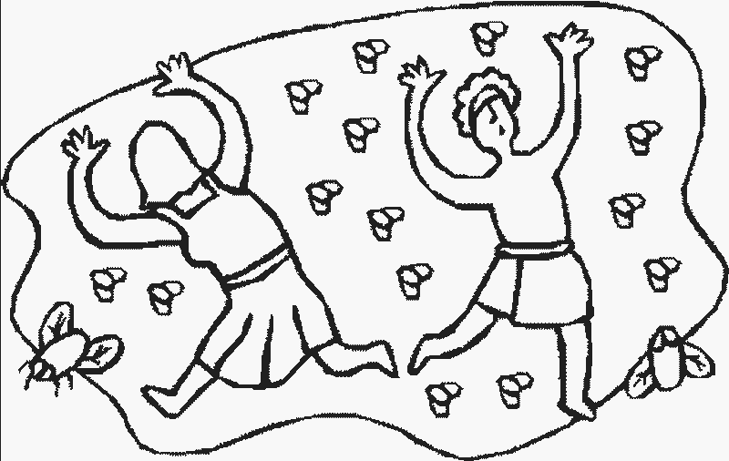  But Pharaoh said, ‘________’.
God sent sickness to the _______________.  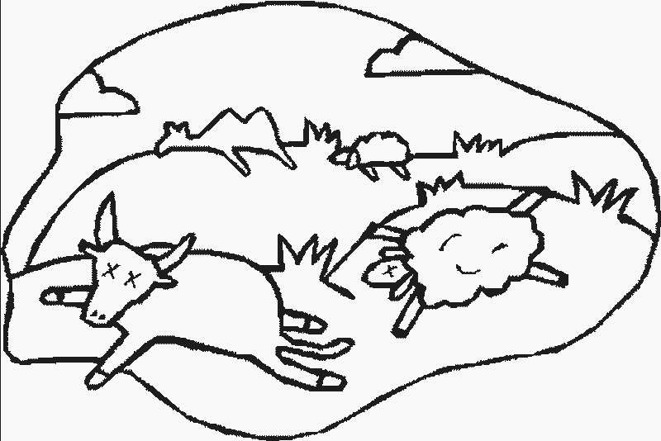  But still Pharaoh said, ‘___________’. | God sent a plague of ____________.  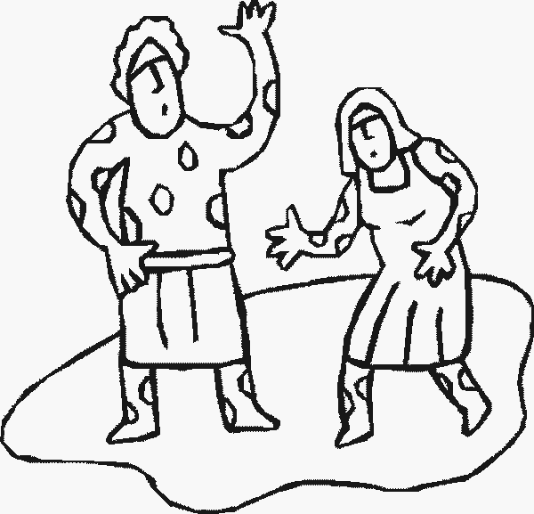  But Pharaoh said, ‘__________’.
God sent a plague of __________.  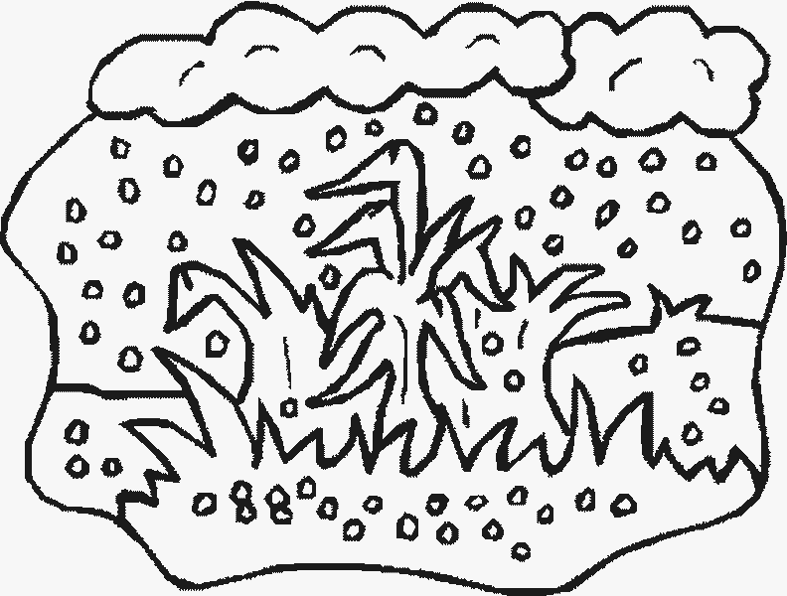  But Pharaoh said, ‘___________’. | God sent a plague of _____________.  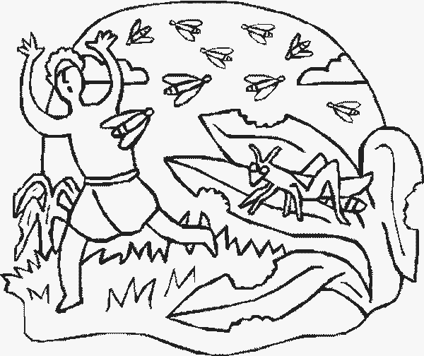  But Pharaoh said, ‘__________’.
God covered the land in _______________  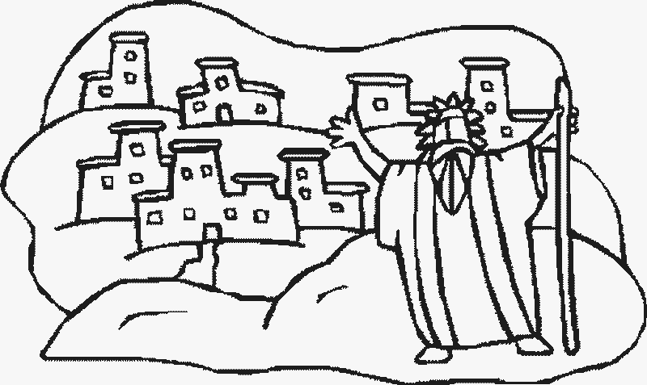  But still Pharaoh said, ‘__________’. | God sent an angel to kill the eldest _________  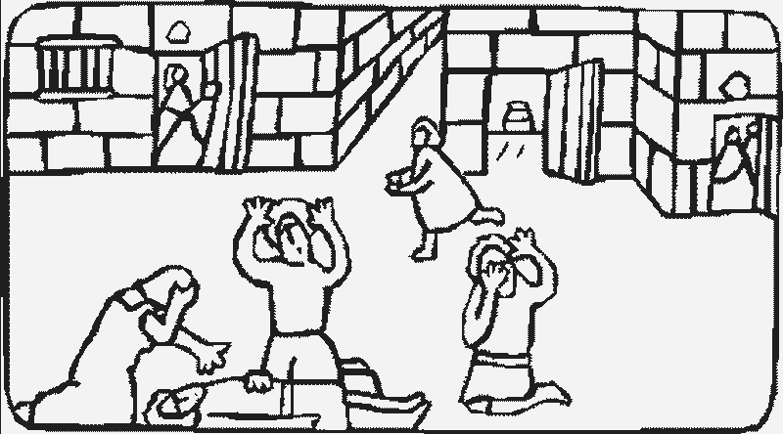  Finally, Pharaoh said, ‘_______’.

And at last Moses could do as God asked and lead the Israelites out of Eygpt.

