CLASS 5 ASSEMBLY

NAME _____________

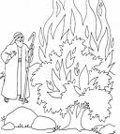

Narrator 1
Good morning, welcome to our class assembly. We are going to tell you the story of one of the most famous people in the Bible His name is…Moses , We are going to tell you the story of how he set his people free.

N2
Moses’ people , the Israelites , were slaves in the land of Egypt. The Egyptians passed a law saying that all the Jewish newborn babies had to be drowned. Now as it happened there was an Israelite woman named Jochebed who had two older children , Miriam and Aaron – But… she also had a new born baby . What was she to do ? Nobody was going to harm her new son .

N3
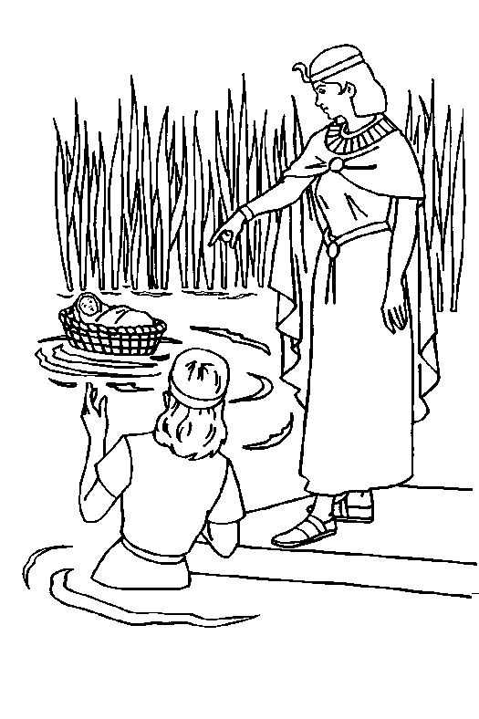
They put the baby in a wicker basket and hid it in the reeds at the edge of the River Nile. Miriam ( the babies big sister ) knew that every morning the Pharaoh’s daughter always came there to bathe. She also knew she was a kind hearted woman. Would their plan work?

N4
As soon as the Princes saw the baby wrapped up snug in his basket, her
heart melted and she fell instantly in love with the infant . She would bring the baby up as her own .

N5
Now Miriam knew that the Princess would need a nanny for the baby so she arranged for her and her mother to be passing, just at the moment the baby was discovered . You’ve guessed it. Yes ! Jochebed the baby’s real mother was asked to be the nurse …

Verse 1
The King came up , with a really dreadful idea ,
That to the Jewish people, would mean hardship and fear,
In the River Nile , their oldest boys we’ll throw ,
The mothers screamed and shouted ,NO !

V2
Jochebed was Miriam’ and Aarons mum ,
Her heart was breaking she was really glum .
She had a new baby , six weeks old
How could she drown him in the Nile so cold.

V3
I’ve got it she yelled and slapped her thigh ,
My little brothers, not going to die,
On the edge of The Nile there’s some marshy ground ,
We’ll leave baby there , where he will be found

V4
The Egyptian Princess, goes there to bathe .
She’s got a soft heart . the baby she’ll save.
The Princess saw baby, lying still in the mud .
She’d keep the child if she possibly could.

V5
I’ll need a nurse , to help me care for the lad ,
She saw a woman sitting there, looking quite sad .
If you can cook and clean, and change a nappy ,
The jobs all yours, I’ll be really happy !

N6
Time passed and Moses grew into man . although he had been brought up as a rich Egyptian , he never forgot his humble roots . Moses and his brother Aaron were the very best of friends and they both cared passionately about the terrible way their people , the Israelites were treated .

N7
One day Moses was walking in the market when he saw an Egyptian , start to beat his Israelite slave . Something in Moses just snapped , he stepped in to put a stop to the dreadful brutality . Unfortunately every thing got out of hand , the Egyptian slipped and before Moses knew what had happened the man lay dead at his feet .

N.8
Moses wanted to stay and face the consequences of what he had done but his family persuaded him to leave the land of Egypt . Moses was smuggled out of Egypt in the dead of night. He went to stay with an uncle who owned a farm . To help pay for his keep, Moses spent most of his time tending the sheep .

V 6
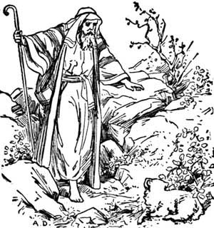
Moses grew up, he became a very rich man ,
This was the best part, of Miriam’s plan .
But he could not forget, the dreadful way,
His people were treated, day after day .

V 7
He strolled down the street , the sun on his back
Behind him he heard , a very loud crack .
A Egyptian stood there, with stick held high ,
He’d an evil glint, in his bark brown eye.

V 8
An Israelite slave, lay face down in the mud ,
His shirt was covered, in his bright red blood.
With his stick he hit, him again and again ,
The poor young slave, was in terrible pain .

V9
Moses got cross, and began to shout ,
He grabbed the Egyptian, and gave him a clout .
The man lost his balance, and banged his head
To everyone’s horror, the man lay dead.

V10
What have you done ? Aaron grabbed his hand ,
You’ll have to flee, getaway from this land !
I want to stay , and have my day in court ,
“ My brothers gone crazy,” Aaron thought.

V 11
In the end Moses sadly , agreed to go
He’d go and work for his uncle Joe
Joe kept sheep, in a land by the sea ,
If Moses went there at least he’d be free.

N.9
One warm summers day , Moses was up in the wild mountain slopes when suddenly the strangest thing happened . Before his eyes, a small bush with beautiful green leaves and red flower, inexplicably burst into flames . A voice from nowhere told him to take off his shoes , he was on Holy Ground .

N .10
The Voice told him he had been selected to rescue his people and to take his brother Aaron with him . They were to return to the Land of Egypt and persuade the Pharaoh to let the Israelites go free . The voice stopped , the fire stopped , and to Moses’ absolute astonishment there wasn’t a mark on the bush . The green leaves and red flowers swayed gently in the warm breeze.

V 12
There wasn’t much grass, for the sheep to eat.
The searching for food , was hard on the feet.
They had to tramp for miles, in the blazing sun
This job’s stupid, it’s really not fun.

V 13
The sheep were stupid, and wandered around ,
Nibbling grass, and things on the ground.
Moses sat down , feeling quite glum ,
He dreamt of his homeland, and especially his mum.

V 14
He looked at a bush - with a hesitant gaze
The middle of the bush was well ablaze.
Out of the sand burst flames and smoke
Moses coughed and began to choke .

V 15
A voice boomed out – it was terribly loud ,
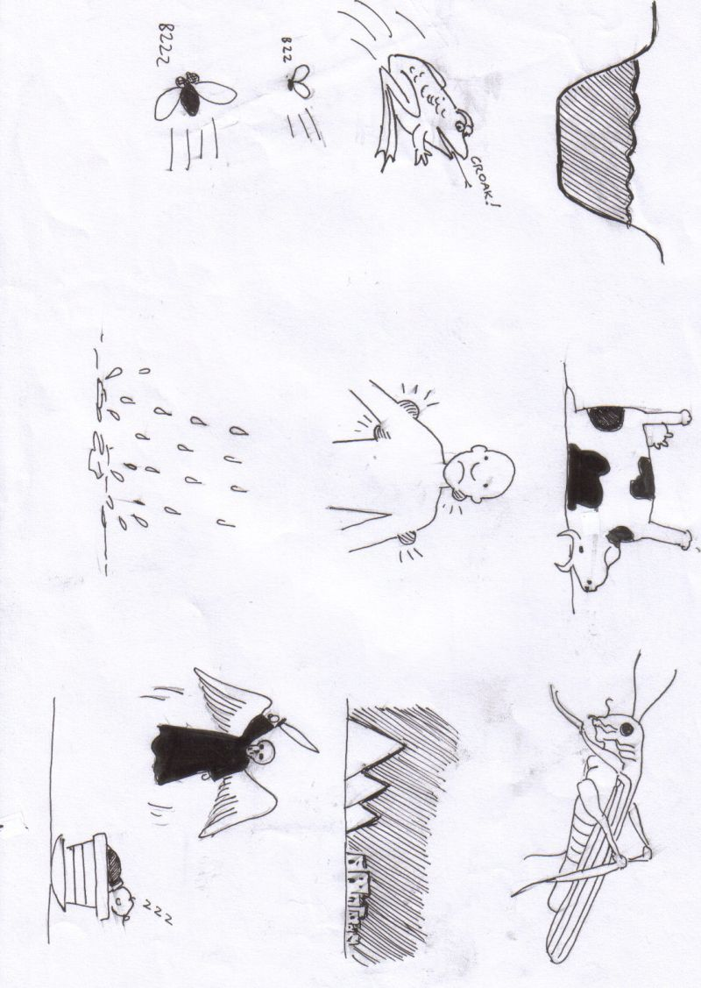
It came from the middle of a fluffy cloud.
“Your people Moses, you must set free
Here’s what to do , now listen to me.”

V 16
“Go back to Egypt , you must be brave ,
The Israelite tribe - you are going to save.”
The fire went out , Moses gave his eyes a rub .
Not a single mark could he find on the shrub.

N .11
Moses and his brother went before the Pharaoh and asked him to release his people . The Egyptian King refused and God sent a terrible plague upon the Egyptians .

N. 12
The King was asked Ten Times and each time something horrible happened . He finally agreed after the tenth plague , but even then he changed his mind after the Israelites had left. The Plagues were as follow i) The River Nile turned to blood : ii) A plague of Frogs covered the land . iii) A plague of insects ; iv) A plague of flies : v) The Cattle died: vi) A plague of boils : vii) Plague : viii) Plague : ix) Three days of darkness ; x) Death of first born Egyptian son.

N 13
This tenth plague was the worst . The eldest son in each Egyptian was to family die . The Israelites were told to kill a lamb, and , with it’s blood paint a red cross on their door . This meant that no one in their house would die. It was said “The Angel of Death” would pass-over their houses leaving them safe. Down through history, to this present day the Jewish people celebrated this is as one of their main feasts, The Feast of The Passover .
As soon as this terrible event happened , the pharaoh agreed to release the Israelites.

V 17
The King looked down - and stroked his cat ,
Moses drew near , he removed his hat .
Pharaoh you’re great, your really cool ,
Moses winked , he was nobodies fool .

V 18
I’ve just got back - from my Uncle Joe,
You must , you must, let my people go .
How dare you - speak, to me like that !
The King stood up quick - and dropped the cat .

V 19
Ten times the Pharaoh , he said NO
I will not - let your people go !
Each time up in Heaven God did frown ,
A plague he sent on the Egyptian
town .

V 20
To the Egyptian people, living there,
The final plague, brought great despair.
The eldest Egyptian boy - must die,
While fast asleep in their beds did lie .

V 21
Jews painted a sign, on the door of each home ,
To tell the Angel of Death , to leave them - alone.
The Jewish homes , he passed over head ,
Only the Egyptian boys, were dead.

V 22
Pharaoh changed his mind - after the final one,
This one where the angel took his son.
Go on, go on, get out of here,
From me your people , have nothing to fear .
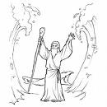
V 23
They gathered their tribe , in one big crowd ,
People laughed and joked , they were really loud!
They carried their goods over their back ,
As Moses led them down the track .

N 14
Just after the Israelites had set off, the Pharaoh changed his mind and sent his army after them, to bring them back. The Israelites reached the edge of The Red Sea where they began to panic because they were trapped .

N 15
The Bible tells us that Moses raised his arms and the water drew back , a passage appeared , the Israelites hurried through and just as they reached the far side, the Egyptian army arrived . They too started to cross the gap , but when they got no more than half way , the waters closed again . Many were drowned and the rest were in no state to chase Moses and his people

V 24
I want my slaves back, I’ve changed my mind ,
He was feeling cross - and really unkind .
He sent his army - at a really fast pace ,
To bring him back - the Jewish race .

V 25
To the edge of the sea , Moses came ,
He looked at the water, and pulled out his cane .
Moses prayed to God - with all his heart
Before their eyes did the waters part !

V 26
The People stared , was it all a dream ,
There was only soil , where water had been .
With all they owned, they crossed the space ,
Relief reflected, in everyone’s face .

V 27
The Egyptian army , came into view
They quickly entered, the same gap too.
They reached half way, and heard a mighty roar !
Back the water, began to pour .

V 28
Their armour was heavy ,it made them sink,
Down , down – down, they went , into the drink.
Water slowly , rose over their head
The whole Egyptian army - was very soon dead!

N 16
The Israelites spent forty years wandering the desert looking for their promised land . During this period they had many adventures . Both good and bad .

THE END

1 |  | MUSIC / OHP | V 27 | V 28
2 |  | MUSIC / OHP | V 27 | V 28
3 |  | N 1 | V 25 | V 26
4 |  | N 2 | V 25 | V 26
5 |  | N 3 | V 23 | V 24
6 |  | N 4 | V 23 | V 24
7 |  | N 5 | V 21 | V 22
8 |  | N 6 | V 21 | V 22
9 |  | N 7 | V 19 | V 20
10 |  | N 8 | V 19 | V 20
11 |  | N 9 | V 17 | V 18
12 |  | N 10 | V 17 | V 18
13 |  | N 11 | V 15 | V 6
14 |  | N 12 | V 15 | V 16
15 |  | N 13 | V 13 | V 14
16 |  | N 13 | V 13 | V 14
17 |  | N 14 | V 11 | V12
18 |  | N 15 | V 11 | V 12
19 |  | N 16 | V 9 | V 10
20 |  |  | V 9 | V 10
21 |  |  | V 7 | V 8
22 |  |  | V 7 | V 8
23 |  |  | V 5 | V 6
24 |  |  | V 5 | V 6
25 |  |  | V 3 | V 4
26 |  |  | V 3 | V 4
27 |  |  | V 1 | V 2
28 |  |  | V 1 | V 2

N | 1 | 2 | 3 | 4 | 5
V | 1 | 2 | 3 | 4 | 5
N | 6 | 7 | 8
V | 6 | 7 | 8 | 9 | 10 | 11
N | 9 | 10
V | 12 | 13 | 14 | 15 | 16
N | 11 | 12 | 13
V | 17 | 18 | 19 | 20 | 21 | 22 | 23
N | 14 | 15
V | 24 | 25 | 26 | 27 | 28
N | 16

HYMNS 1.
2.

THE PLAGUES

