Name: Date:
What is Shabbat?
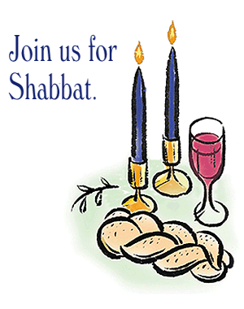

is a day of rest. Is represents that God made the world in days and on the day He rested.

is the Hebrew name for the day we call the .
Shabbat is a day of great joy eagerly awaited throughout the week, a time when can set aside all of their weekday concerns and devote themselves to God.
The Sabbath day is important to Jews because it is stated in
the Commandments.
The word ‘Shabbat’ means to or to .

The Sabbath begins on afternoon, when the house is cleaned, the family bathes and dresses up, the best dishes and tableware are set, a festive meal is prepared.
Also, everything that cannot be done during Shabbat must be set up beforehand. For this reason, a popular Sabbath meal is , a slow-cooked stew.
Before the meal ____ ______ are lit. On Shabbat the meal begins with a blessing said over ___ ____ and two loaves of _________.

Jewish families have the meal at the dining table with a __________ tablecloth and the best __________ and .

Jews spend time in praying, prayer is not what distinguishes Shabbat from the rest of the week.
Shabbat is a very full day when it is properly observed, and very relaxing. You really don't miss being unable to turn on the TV, drive a car or go .
Synagogue | rest | Friday | Sabbath | cease | six
Ten | Shabbat | seventh | cholent | shopping | Jews
bread | candles | white | wine | silver | cutlery

