HOMEWORK: Look at the diagrams below and answer the questions.
LO: To revise the process of the Reproductive organs inside a flower

1) The job of making new plants is done by the F _ _ _ _ _ _ .
2) The flowers contain P _ _ _ _ _ and E_ _ s, which make S_ _ _ _ _.
3) The S _ _ _s grown into new plants.
4) Look at the diagram below and each part of the plant and it’s job, colour in the diagram and highlight any words to help you remember.

ANTHER contains POLLEN
STAMEN = MALE
Contains pollen grains.

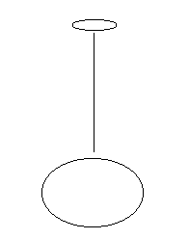
FILAMENT holds the ANTHER up
Stigma is sticky to catch pollen
STYLE holds the stigma up
Ovary contains eggs
CARPEL = FEMALE
Contains the eggs

