Irreversible Changes

A material changes into a completely new and different material.
The new material can not be changed back to what it was before.

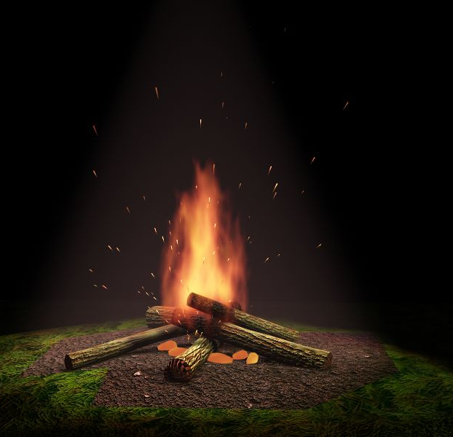
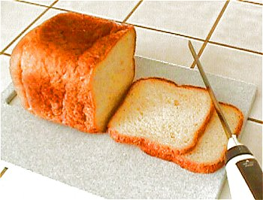
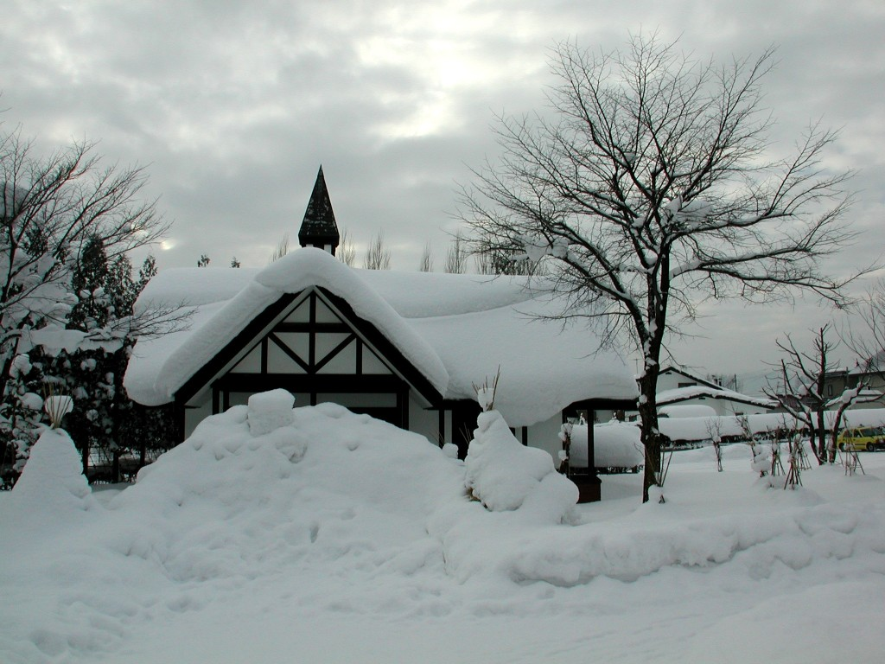
Wood and Paper
burn to ash.
Flour, water
and yeast are
baked to make
bread
Water turns into
snow or ice
when it gets
very cold.
When it warms up
it turns back to water.
Reversible Changes

In a reversible change a material turns into something that looks and feels different, but is not changed forever.

It can be changed back to its original state.
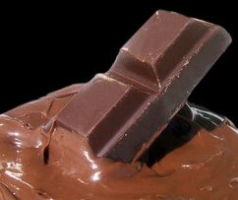
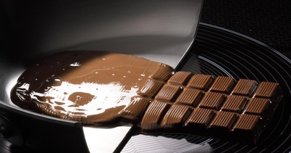
Melting
When a solid warms up and turns into a liquid.
Chocolate goes
soft and gooey
if you heat it.
Cool it down and
it goes hard again.
Condensation
When water vapour cools and turns to liquid.

make bread.
Freezing
When a liquid gets cold enough to turn into a solid.
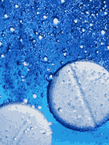
Evaporation
When a liquid warms up and starts to turn into a gas.
Dissolve
When a solid mixes into a liquid and just leaves a new liquid.

