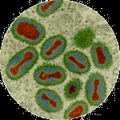
Edward Jenner and his Cure for Smallpox
This is the smallpox virus. It has been magnified using a microscope.
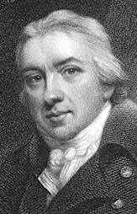
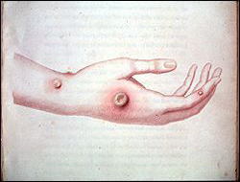
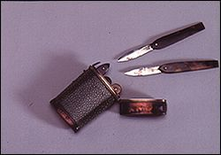
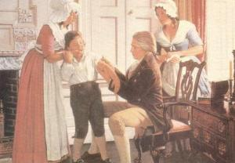
Edward Jenner studied medicine from an early age and became a skilful and popular doctor. During his time, smallpox was a common and very serious disease and many people who caught it, died.
From talking to other people and from making observations of milkmaids, Jenner realised that milkmaids that had caught cowpox did not seem to catch smallpox. He got the idea that cowpox immunised people against smallpox.
He found a milkmaid that had caught cowpox and decided to carry out some investigations. He took some matter from the pustules on the milkmaid’s hand using the blade on his knife.
Cowpox pustules
He infected a young boy with cowpox by scratching his skin with the knife blade that had touched puss from the pustules of the milkmaid.
The boy developed a slight fever from the cowpox but nothing serious. Soon afterwards, Jenner infected the boy with smallpox in the same way as before. The boy did not develop smallpox. Jenner discovered that the boy’s body had built up resistance to the disease and had become immune to smallpox by being given a mild dose of the less dangerous disease cowpox. Jenner named this process vaccination. Jenner’s work led the way for the development of many more vaccines to protect us from disfiguring and fatal diseases.

