Labelling Forces

You are going to label these diagrams with the correct forces, making sure you show which force has the most power.

Car
This car is moving forward, where will you place the arrows to show the forces of: gravity, propulsion, air resistance and friction?
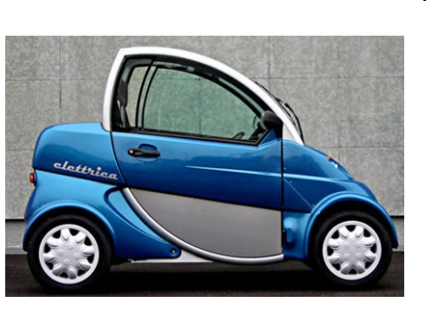

Rubber duck

This rubber duck is floating happily in the bath, where will you place the following forces: gravity and upthrust?

