 | Miss Smith | Science-Humans and Animals | Year Four (8-9)
Date/Duration | Learning Objective | Activities | Resources | Assessment
Lesson 3  1 hour | To understand that food chains show feeding relationships (humans)  To know that nearly all food chains start with a green plant (producer) | - Write human in the middle of the page. What types of food do we eat? Meat, veg, Fruit, sugar, pasts etc.. What are many humans? Omnivores… What does this mean? Eat meat and vegetables. List 5 things that you eat (Minimum).  - Where do these things come from? Grown on a tree, underground, made from different ingredients, from an animal.  - List diary products, milk, cheese, butter, yoghurt, and cottage cheese. Present a few ideas  - Why are they called dairy product? What do they all have in common? MILK. Record this in their books.  - Where does milk come from? Cows  - What do cows eat? Grass  - Can we find a chain of events from the grass to the human? Give out cards and sequence events x4 cards each, grass, cow, milk, human. Stick the cards in their book.  - Discuss this is a food chain. Can you add arrows to show the direction that they are eaten or produced?  - Explain that all food chains usually start with a plant. We call this a producer. Where do plants get their food? Plants make their own food. They are called producers because they produce and make their food. They use the energy from the sun to grow.  - List different plants that they know. High and mid ability write a statement about the plants being a producer and being the start of the food chain.  - Complete the worksheet on food chains. Low (with support) and Mid(without support) ability cut out pictures and put in a food chain. Remember the arrow mean is eaten by. Complete Food chain 1  - Mid to High ability complete worksheet Food chains 2  - High ability complete worksheet Food chain 3  - Complete the conclusion sheet x 2 levels  Level 1= low ability with support  Level 2 = mid to low ability without support  Level 3 = mid ability  Level 4 = high ability | - sequence events x4 cards each, grass, cow, milk, human x25 sets  - worksheet Food chains x3 levels  - picture of animal and plants to be put into a food chain x12  - Conclusion sheet x 2 levels

Food Chains 1
Levels 1&2
Fox Grass Rabbit
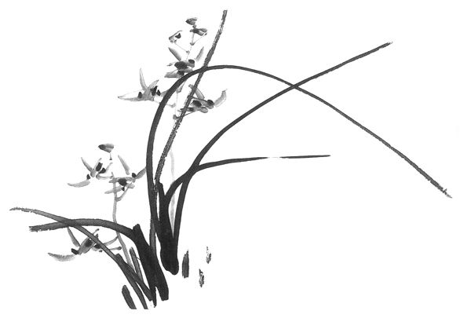

- Write these as a food chain

Producer Prey Predator

- Kestrel (bird) Slug Frog Lettuce
Write this as a food chain.

Producer Prey Prey Predator

- Look at this food chain:
Ash Tree Greenfly Frog

Label the food chain using producer, a herbivore and a carnivore.

- Why is the sun important for all living things in a food chain?

use the sun to make energy. Nearly all food chains start with a

Food Chains 2
Level 3
Fox Grass Rabbit

1. Write these as a food chain

Producer Prey Predator

- Kestrel (bird) Slug Frog Lettuce
Write this as a food chain.

Producer Prey Prey Predator

- Make two food chains from the list of animals and plants below.
Cat Dead Leaves Fox Grass Worm Rabbit Blackbird

A)

B)

- Look at this food chain:
Ash Tree Greenfly Frog Snake

Label the food chain using producer, a herbivore and a carnivore.

- Why is the sun important for all living things in a food chain?
Food Chains 3
Level 4
Fox Grass Rabbit

- Write these as a food chain

Producer Prey Predator

- Kestrel (bird) Slug Frog Lettuce
Write this as a food chain.

Producer Prey Prey Predator

- Make two food chains from the list of animals and plants below.
Cat Dead Leaves Fox Grass Worm Rabbit Blackbird

A)

B)

- Look at this food chain:
Ash Tree Greenfly Frog Snake

Label the food chain using producer, a herbivore and a carnivore.
- Why is the sun important for all living things in a food chain?

- In these pairs of animals decide which the prey is and which is the predator?
Cats eating a mouse Fox eating a rabbit

Conclusion
Levels 1&2
What have you learnt this week?

foodplants Cheese
yoghurt fromcows
greensungrow
animals grassmilk

Some of the__________ we eat comes from ___________ and some come directly from _________.
__________, butter, __________and cream come from ____________. Most of the milk we use comes from ________.
Cows get their food from ___________.
A food chain shows where our food has come _______.
Nearly all food chains start with a ________plant that needs the _________in order to ____________.
Conclusion
Levels 3&4
What have you learnt this week?

Where does the food we eat come from?

Name products that come from milk?

Where does milk come from?

Where do cows get their food from?

What does a food chain show?

What do the direction of the arrows in a food chain mean?

What do nearly all food chains start with?

Name a producer?

Name a herbivore?

Name a carnivore?

