LO: To understand that condensation is when a gas turns into a liquid.

How does condensation occur in each picture? Think of one of your own.

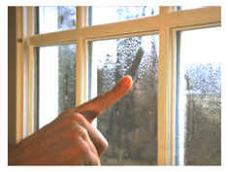
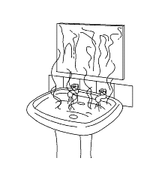

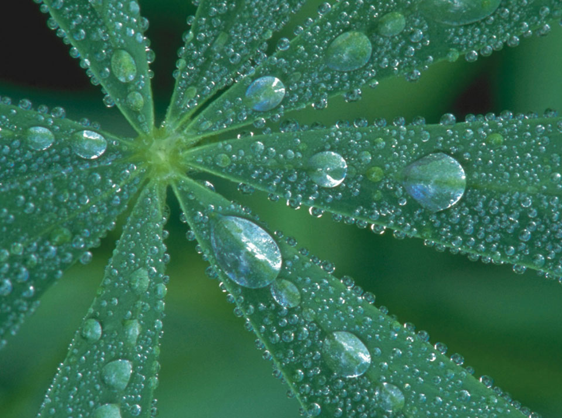

LO: To understand that condensation id when a gas turns into a liquid.

Find the examples of condensation on this page, cut them out and then stick them in your book. Then explain one to an adult.

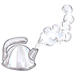 | 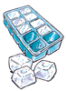
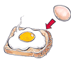 |  | 
 |  | 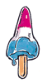

LO: That evaporation is when a liquid turns to a gas.

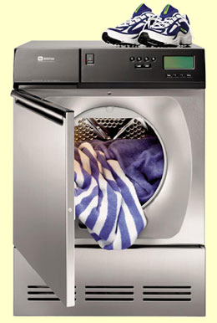

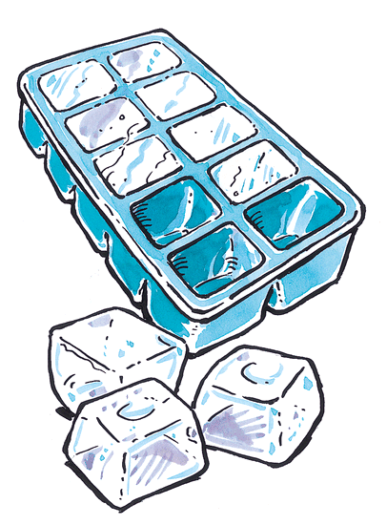 | 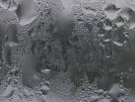
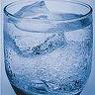 |  |  | 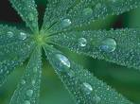
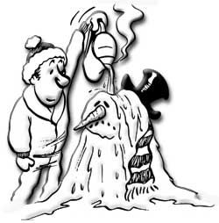 | 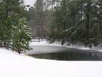 | Evaporation | When a solid changes into a liquid.  (by gaining heat)
Condensation | When water vapour from the air meets a cold surface it condenses. | When a liquid changes into a solid  (by losing heat) | When a gas turns into a liquid
Freezing (Solidifying) | When a liquid turns into a gas | Melting | When a liquid is heated it turns into water vapour and rises into the air.

