Name Date

Science: Earth, Sun & Moon

- Match the pictures up with the sentences.

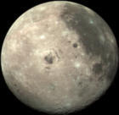 | This spins around on its axis every 24 hours.
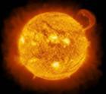 | This is Earth’s satellite.
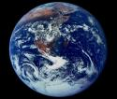 | This is a star.

- Match the sentences with the labels.

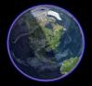

The part of the earth that is facing the Sun has daytime.
The part of the Earth that is facing away from the Sun has nighttime.
The Sun is 1 million times bigger than the Earth.

