Floating and Sinking

If two objects have the same mass will they both float? ____________

Why? __________________________________________________

_______________________________________________________

Investigate

1) Get a bowl and fill it with 2 pints of water.
2) Get a lump of plasticine.
3) Weigh the plasticine and make a note of its mass.
4) Mould the plasticine into a shape.
5) Make a prediction, do you think it will float or sink?
6) Put your shape in the water.
7) Note the results in the table.

Shape  Draw a picture of the shape below. | Mass | Float or Sink?
Shape  Draw a picture of the shape below. | Mass | Prediction | Result

What did you find out?

___________________________________________________________________________________________________________________________

Why do you think this happened?

Now answer the first question again. Is your answer the same?
If two objects have the same mass will they both float? ____________

Why? __________________________________________________

_______________________________________________________
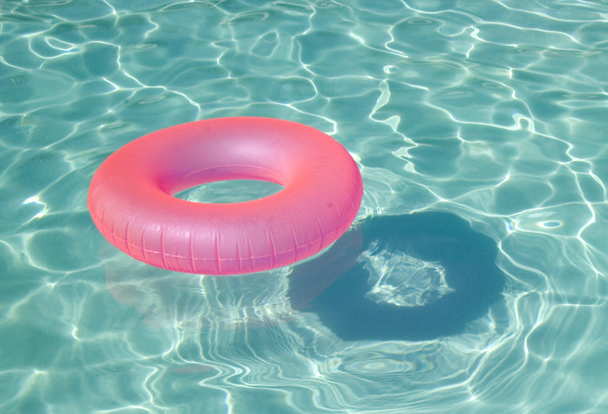
I flattened out my plasticine
And set it in the tank
And do you know the cheeky thing
Turned round and slowly sank.

But when I took it out again
And shaped it like a boat
It wasn’t cheeky anymore
For it began to float.

Albert Crawford

